Name:

Date:

School:

Facilitator:

1.05 Third Person Description Writing

**Scenario**

This is a picture of Monsieur Renat. He is not doing very well today. He is originally from Lille, but he is now living in Strasbourg.

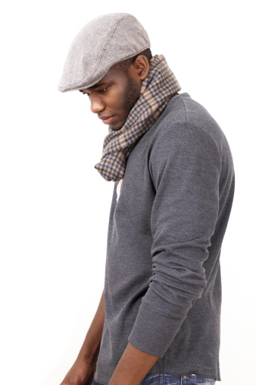

1. Comment s'appelle l'homme?

1. Comment va l'homme?

1. D' où vient l'homme?

1. Où habite l'homme?