Name:

Date:

School:

Facilitator:

6.05 Ignitable Liquids (50 Points)

# Recovering Ignitable Liquids

**Gather information about at least three methods investigators use to identify the presence of ignitable liquids. Describe how the method is used and some advantages and disadvantages of that method.**

|  |  |  |  |
| --- | --- | --- | --- |
| **Method to identify ignitable liquids** (1 point each) | **Describe how it is used** (2 points each) | **Advantages** (2 points each) | **Disadvantages** (2 points each) |
| **1.** |  |  |  |
| **2.** |  |  |  |
| **3.** |  |  |  |

**4. As an investigator, which method would you choose to search for ignitable liquids at the scene of a recent apartment fire? Explain your reasoning.** (2 points)

**Select three of the following types of evidence and describe the process for collecting them during a fire investigation.**

**Types of evidence: carpet, tile, cement, linoleum, sand or soil, wood flooring**

|  |  |  |
| --- | --- | --- |
| **Type of evidence** | **Best portion/location to collect from** (2 points) | **How to collect** (2 points) |
| **5.** |  |  |
| **6.** |  |  |
| **7.** |  |  |

**8. Which of these types of material will likely contain the most useful amount of ignitable liquid evidence? Explain.** (2 points)

9. What type of container is best for packaging these types of evidence? (2 points)

11. Explain what a reference sample is and why it is collected. (3 points)

# Analyzing Evidence

11. What two methods are utilized to analyze ignitable liquids after they are collected and transported to the lab? (2 points)

Examine the graph below and answer the following questions.

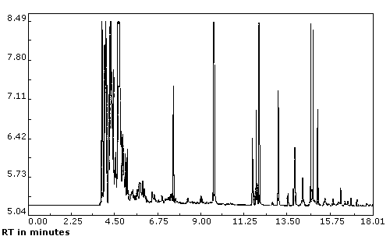

C

A

B

**(**[**https://www.osha.gov/dts/sltc/methods/partial/pv2028/gasolinefig1.gif**](https://www.osha.gov/dts/sltc/methods/partial/pv2028/gasolinefig1.gif)**)**

12. What method was utilized to prepare this graph? Explain your reasoning. (2 point)

13. Which of the labeled components of this sample was most attracted to the stationary phase? Explain your reasoning. (2 points)

14. Which of the labeled components of this sample was present in the greatest abundance in the mixture? Explain your reasoning. (2 points)