Name:
Date:
School:
Facilitator:

4.03 Analyze a Case (45 Points)

Part 1: Spatter size
1. A police officer is called to a school fight where one student is accused of knocking another student out in a fight. According to the 911 call, the victim was punched while unconscious on the ground. Student witnesses on the scene say that this is not correct. Instead, the victim was punched in the nose and suffered a nosebleed, but he was not knocked out or nor knocked to the ground. The blood spatter includes only very large blood droplets. Based on this evidence, which scenario is correct? Explain your answer. (5 points)
Write your response below in complete sentences.

2. Describe an experiment that could be done to test your conclusion from the above scenario. In your described procedure, utilize the following materials: (5 points)
- Eye dropper or pipette
- Artificial blood
- Meter stick, measuring tape, or ruler
Write your procedure below. You may use bullet points to describe the experiment.

Part 2: Angle of Impact
View the videos for this section on the 4.03 Task page.
3. Each video clip is labeled with an angle of impact; you will be re-calculating these angles of impact using your own measurements to ensure that our video clips are accurate and ready for the court room and that you can explain to the jury how we arrived at those angles. Measure the width and length of each of the blood drops in millimeters directly on your screen, or you can use the grid lines that are provided in the video. Each grid line would equal 1 unit. Estimate the measurement to 1 decimal place if it does not fall directly on a grid line. Complete the data table below with the information as requested. (1 point per cell)

Angle as labeled in video | Measured width | Measured length | W/L (decimal) | Calculated Angle (using Trig. table 1 below) | Does your  calculated angle match the given angle?
(Example)10° | 2 units | 15 units (note tail is not included) | 2/15=.133 | 8° | No, it is off by 2°
30°
50°
70°
90°

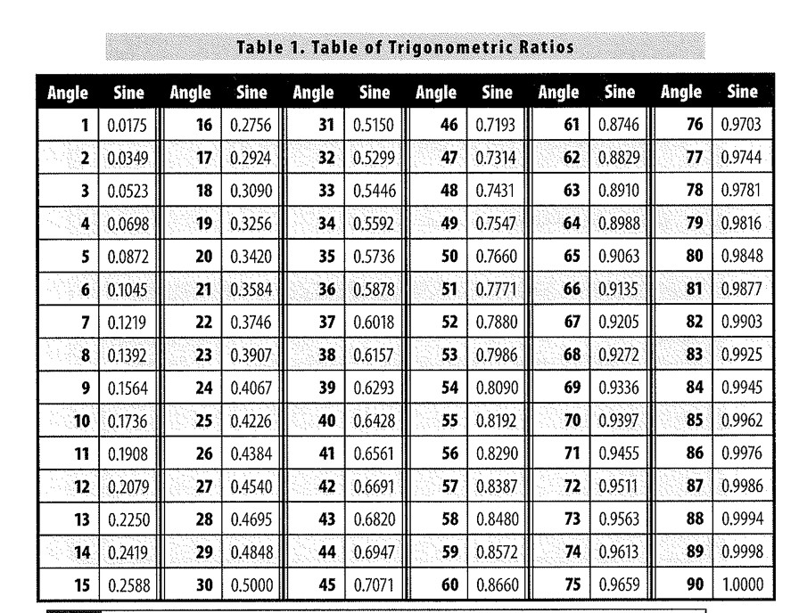

Part 3: Categorize Stains
As a bloodstain pattern analyst, you have been called to the following scene by the police investigator. The apartment caretaker found the following blood patterns in the building and within suite 203. The resident in suite 203 cannot be located and it is not known who the victim is, or what the person's injuries might be.

Part 4: Staircase
The first photograph is going up to the second floor from the apartment entrance foyer, then there is a turn to the right passing the next photo.
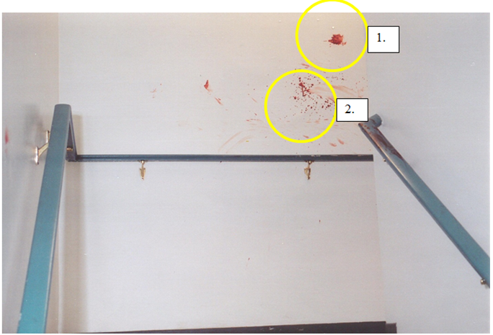

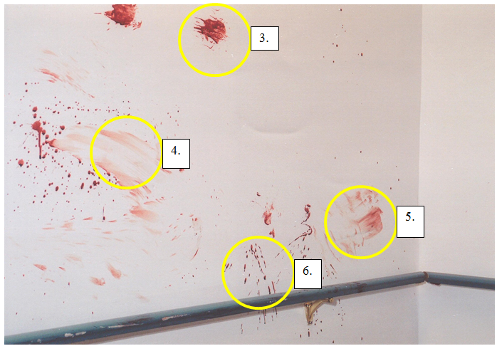4. Label the stains in each picture as passive, transfer, or projected stains. Provide one reason / possible source for the stain. (1 point each)
Stain 1: Type of stain:
Reason / Source:
Stain 2: Type of stain:
Reason / Source:
Stain 3: Type of stain:
Reason / Source:
Stain 4: Type of stain:
Reason / Source:
Stain 5: Type of stain:
Reason / Source:
Stain 6: Type of stain:
Reason / Source:

5. Do you think the attack occurred here? Explain why or why not. (3 points)

