Name:
Date:
School:
Facilitator:

2.08 Glass Evidence (32 Points)

Part 1: Density
Answer the following questions about glass density. Use the glass type and density table to answer the first 4 questions. (2 points per question)
Glass Type | Density (g/mL)
UV-blocking glass | 2.21
Bottle glass | 2.4
iPhone screen | 2.45
Window glass | 2.5
Lead crystal vase | 3.1

- What is the density and probable identity of a sample of glass with a mass of 37.4 g and a volume of 15.2 mL?
- What is the density and probable identity of a sample of glass with a mass of 44.2 g and a volume of 20.0 mL?
- A piece of glass sinks in a liquid with a density of 2.6 g/mL. Which type(s) of glass could it be?
- A piece of glass floats in a liquid with a density of 2.6 g/mL. Which type(s) of glass could it be?
- A small piece of glass was collected from the clothing of a burglary suspect. A large piece of glass was also collected from the broken windowpane. If these two pieces are from the same window, they (may/will) have the same density because density is an (extensive/intensive) property of the window glass.

- To determine the density of a piece of glass, a forensic technician places the glass in a liquid with a density of 2.1 g/mL. The glass sinks. What should the technician do now?
  - Record that the density is greater than 2.1 g/mL and stop the analysis.
  - Add a liquid with a density less than 2.1 g/mL until the glass begins to float.
  - Add a liquid with a density greater than 2.1 g/mL until the glass begins to float.
  - Record that the density is less than 2.1 g/mL and stop the analysis.
Answer:
- Two samples of glass were placed in a liquid with a density of 2.6 g/mL. One of the pieces of glass floated and the other sunk. Are these from the same source or is further analysis needed to determine if they are from the same source? Why or why not? (3 points)
Write your response below:

Part 2: Collection and Analysis
Answer the following questions about glass evidence collection and analysis.
- Small glass fragments may be found on articles of clothing or shoes. Describe the proper procedure for collecting and packaging a shirt with glass fragments on it. (3 points)
Write your response below:

- Describe what information you should record to determine the direction of impact. (3 points)
Write your response below:

- Look at the image below and describe the type of fracture and which side of the glass as the impact the A and B lines are on.
  - “A” = fracture and on the side of the glass as the impact (2 points)
  - “B” = fracture and on the side of the glass as the impact (2 points)
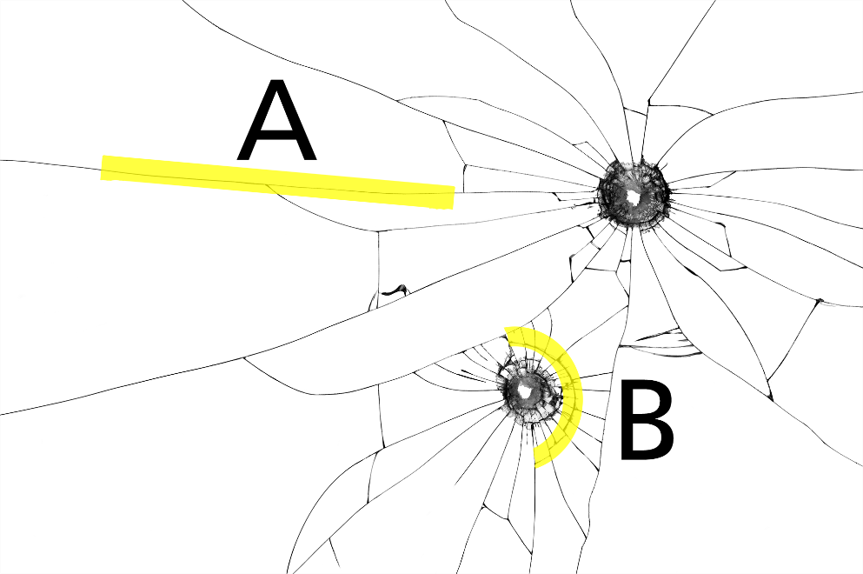
- When Micah came home from work, he found that the window in the living room was broken. His teenage daughter claimed that her brother broke the window while practicing golf outside that afternoon. He claimed that she broke the window while throwing her baton inside. When Micah felt the broken glass, he noticed that the concentric fractures were on the inside of the glass while the radial fractures were on the outside. Which child is guilty? (3 points)

- UV light is used to check a piece of glass for . (1 point)

- Placing the glass sample in a liquid, shining a light on it, and varying the composition of the liquid until Becke Lines disappear is a method of determining the of the glass. (1 point)

- Which of these steps is the simplest and should be performed first when comparing two pieces of glass? (2 points)
  - determination of the refractive index
  - determination of the density
  - determination of the color
  - determination of the elemental composition
Answer:

