Name:
Date:
School:
Facilitator:

3.01 Sticky Fingers
Three weeks ago a local bakery was robbed at gunpoint. The thief wore a mask, so even when the police found a suspect, the bakery owner couldn’t make a positive ID. However, as the CSI processing the scene, you collected several fingerprints from various parts of the bakery.
The police have identified a suspect, but he says he’s never been to that bakery. It’s your job to see if the suspect’s fingerprints match any of those recovered at the scene of the crime.
Look at how the fingerprints from the crime scene have been labeled. Ask yourself:
- Do any ridges enter and exit on the same side of the finger?
- Do the ridges form a circular pattern?
- Do all ridges run from one side of the finger to the other?
bifurcation

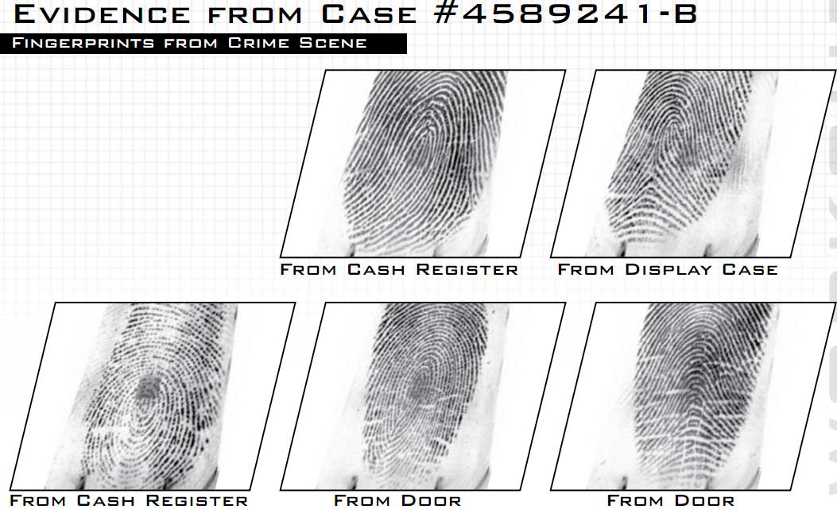

enclosure

island

ridge ending

bifurcation

enclosure

ridge dot

bifurcation

ridge dot

ridge ending

bifurcation

ridge ending
Loop
Loop

ridge ending

delta

island

bifurcation
bifurcation

bifurcation

delta

island

spur

ridge ending
Arch - plain
Whorl – central pocket
Whorl - plain

1. Now, it is your turn. Label each of the suspect’s prints as an arch, loop, or whorl. Remember to look at where ridges enter and exit the finger and to look for a circular pattern. If possible, tell which arch (tented or plain), loop (ulnar or radial – pay attention to left or right hand), or whorl (plain, central pocket, double loop, or accidental) each finger is classified.
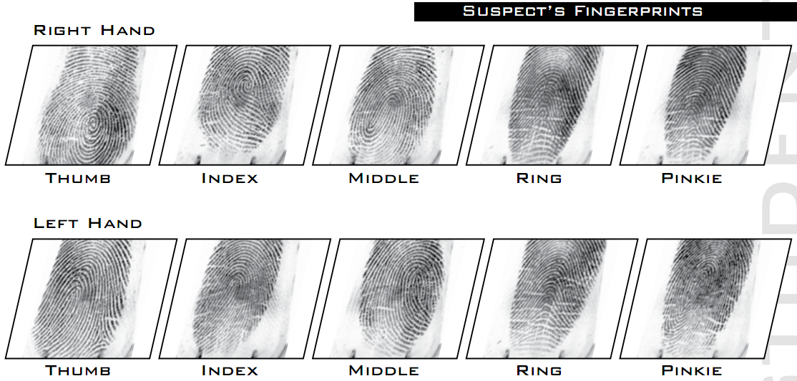

J.

H.

I.

G.

F.

E.

D.

C.

B.

A.

3. Identify the highlighted minutiae ridge characteristics above.
A. | F.
B. | G.
C. | H.
D. | I.
E. | J.

2. Do any of the crime scene fingerprints match the suspect’s fingerprints? Label any matching crime scene fingerprints with the hand and finger they come from.
- From Cash Register (top row) =
- From Display Case =
- From Cash Register (bottom row) =
- From Door =
- From Door =

3. Do any of the crime scene prints NOT match the suspect’s prints? Who do you think could have contributed these prints?

4. Do you think the suspect committed this crime? Why or why not?

bifurcation

bifurcation

bifurcation

