Name:

Date:

School:

Facilitator:

2.03 Individualized Evidence

**Observe each picture associated with each set of questions. Unless indicated assume there are no fingerprints or DNA collected from evidence. Be sure you explain your answers.**

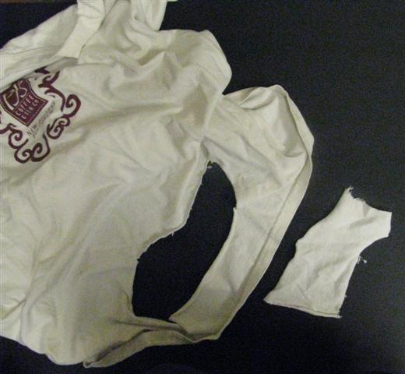

**Evidence 1:**

A piece of torn clothing was found at a crime scene. A torn t-shirt was found in one of the suspect’s car.

**1.** Can the torn clothing from the crime scene be individualized to the t-shirt found in the car? Why or why not?

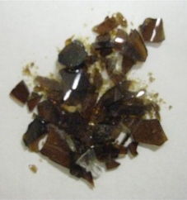 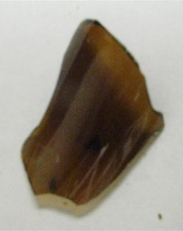

small glass fragments large glass fragment

**Evidence 2:**

Small pieces of glass were found in a suspect’s shirt pocket of a breaking and entering crime. In this crime, the burglar broke a window to enter the home.

**2.** Are the pieces of small glass considered class or individual evidence? Explain.      

**3.** What if the pieces of glass were large pieces that could be pieced back together in the window, would it be considered class or individual evidence? Explain

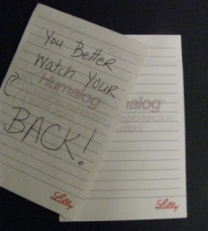

**Evidence 3:**

A bank robbery turned up a threatening hand written note. A suspect that worked at the bank had a similar notepad on his desk.

**4.** Could the handwriting be considered class or individual evidence? Explain.      

**5.** What about the notepad?      

**6.** Is it possible for forensic scientists to determine if a ransom note came from a certain notepad? If yes, tell at least one way how they would be able to match them.      

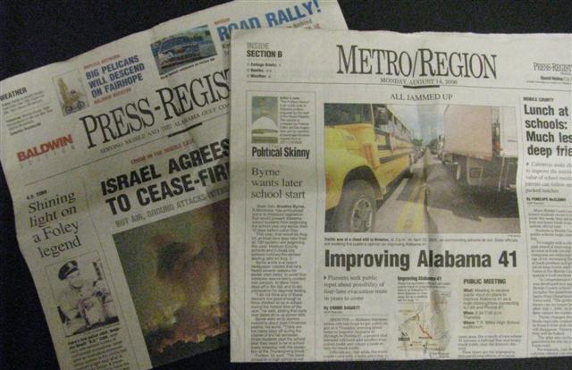

**Evidence 4:**

A local newspaper was found at a crime scene but it was missing Section B. A Section B was found in the home of a suspect.

**7.** Is Section B individual or class evidence? Explain.