**Name:**

**Date:**

**School:**

**Facilitator:**

* 1. Population Growth

**Directions: Read the following information below. Use the information below, as well as what you learned in the lesson content to complete the table and answer the questions about population growth.**

Exponential population growth cannot continue forever, since all organisms require resources to grow and reproduce, and the environment where a population is growing has a limited supply of resources (e.g. a limited supply of food or water). As a population gets larger, there is increasing competition for resources. This results in decreased reproduction and/or increased mortality, so the rate of population growth slows down. Eventually, the population will reach a maximum size which is called the carrying capacity of the environment; the carrying capacity depends on the amount of resources available in the environment. The second figure illustrates this type of logistic population growth with a carrying capacity = K.

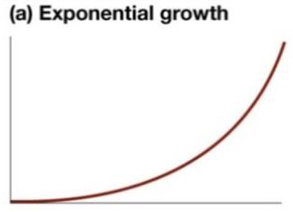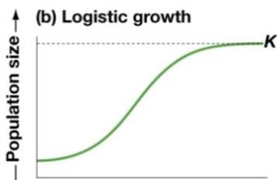

1. Suppose a single bacterium is placed in a flask that contains lots of food for bacteria. In this flask, each bacterium grows and divides in two every 30 minutes. Therefore, the number of bacteria in the population doubles every 30 minutes. How many bacteria do you think there will be by 5 hours after the single bacterium is placed in the flask? Give it your best guess.
2. Complete the table to calculate how many bacteria there will be at each time.

|  |  |
| --- | --- |
| 1 | bacterium at the beginning = 0 minutes |
| 2 | bacteria by 30 minutes |
| 4 | bacteria by 1 hour |
| 8 | bacteria by 1 hour and 30 minutes |
|  | bacteria by 2 hours |
|  | bacteria by 2 hours and 30 minutes |
|  | bacteria by 3 hours |
|  | bacteria by 3 hours and 30 minutes |
|  | bacteria by 4 hours |
|  | bacteria by 4 hours and 30 minutes |
|  | bacteria by 5 hours |

1. How long would it take for the bacteria to go from 1 bacterium to 500 bacteria?
2. How long would it take for the bacteria population to increase from 500 to 1,000 bacteria?
3. Think back to the limiting factors that were discussed during the lesson. What factors will cause the bacteria to stop exponential growth? These are the same factors that create an ecosystem’s carrying capacity. [List 2 factors.] Are the factors you listed density-dependent or density-independent? Explain?



1. Based on the data you collected in question # 2, if you were to graph with the time on the X (horizontal) axis and the number of bacteria on the Y (vertical) axis, how would your graph look? Would it look like the Exponential growth (J-curve) (a) above? Or, like the Logistic growth curve (S-curve) (b) above? You might want to sketch out a graph to get the answer.
2. What would your graph look like when there are limiting factors that would create a carrying capacity for the container? Would it look like the Exponential growth (J-curve) (a) above? Or, like the Logistic growth curve (S-curve) (b) above?
3. Using what you learned in Unit 1 about biomes, list a possible density-independent factor for the

Tundra

Desert

Rainforest

Deciduous Forest

Taiga

Grassland