**Name:**

**Date:**

**School:**

**Facilitator:**

* 1. Abiotic and Biotic Factors

**Directions:** Study the picture below from Delta Education and list 3 abiotic factors and 5 biotic factors that are present in the picture. Then list 3 more abiotic factors and 3 more biotic factors in the picture below that cannot be seen but you know are present. (Hint: the factors may be microscopic. Be sure to look in the air, ground, and water.).

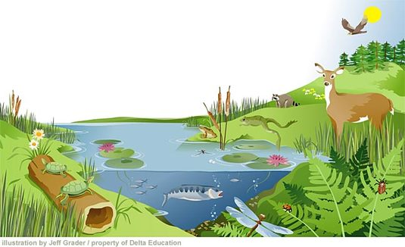

Visible Abiotic Factors:



Visible Biotic Factors:



Microscopic Abiotic Factors:



Microscopic Biotic Factors: