Name:

Date:

School:

Facilitator:

2.03 Why Should I Care?

**Determine the author’s purpose for each of the following examples. Then, explain how you determined the author’s purpose. Be sure to use complete sentences and appropriate grammar and spelling.**

Total Points: 40

# Example:

Rain

by Robert Louis Stevenson

The rain is raining all around,  
It falls on field and tree,  
It rains on the umbrellas here,  
And on the ships at sea.

Purpose: entertain

Explanation: Poems are generally meant to entertain. The author is not attempting to persuade the reader of anything nor to provide facts.

1. 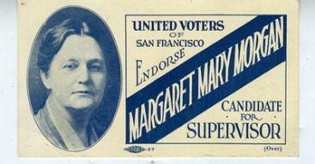

Margaret Mary Morgan political campaign card, 1921. Image is public domain.

Purpose:

Explanation:

2. "What's gone with that boy, I wonder? You TOM!"

No answer.

The old lady pulled her spectacles down and looked over them about the room; then she put them up and looked out under them. She seldom or never looked THROUGH them for so small a thing as a boy; they were her state pair, the pride of her heart, and were built for "style," not service—she could have seen through a pair of stove–lids just as well. She looked perplexed for a moment, and then said, not fiercely, but still loud enough for the furniture to hear:

"Well, I lay if I get hold of you I'll—"

She did not finish, for by this time she was bending down and punching under the bed with the broom, and so she needed breath to punctuate the punches with. She resurrected nothing but the cat. (from Mark Twain’s *The Adventures of Tom Sawyer*)

Purpose:

Explanation:

3. demote (v.) – to give someone a lower rank, usually as punishment

Purpose:

Explanation:

4. “Gentlemen may cry, Peace, Peace – but there is no peace. The war is actually begun! The next gale that sweeps from the north will bring to our ears the clash of resounding arms! Our brethren are already in the field! Why stand we here idle? What is it that gentlemen wish? What would they have? Is life so dear, or peace so sweet, as to be purchased at the price of chains and slavery? Forbid it, Almighty God! I know not what course others may take; but as for me, give me liberty or give me death!” (from Patrick Henry’s “Speech to the Virginia Convention”)

Purpose:

Explanation:

5. 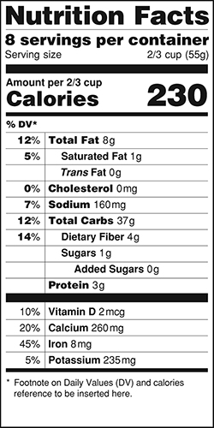

U.S. Food and Drug Administration Nutrition Label. Image is public domain.

Purpose:

Explanation: