Name:
Date:
Facilitator:
School:

5.01 Local Color

Part A – Focus
The term prairie schooner shows how Easterners used familiar terms of sea travel for their new adventure of settling the West. Traveling from the Atlantic coast to the Western territories typically took at least six months. Harsh weather, Indian raids, limited supplies, and disease were among the trials that settlers faced.
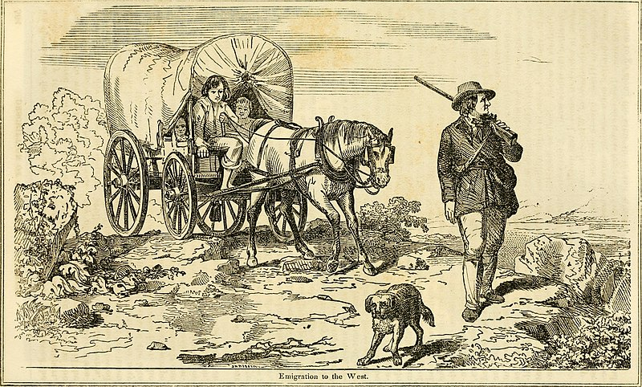
1. What do you think the West represented to those willing to risk such a journey?

As the nation grew in the late 1800s, so did writing and publishing. Eastern monthly magazines like Harper's Bazaar and The Atlantic Monthly sought writers who lived or traveled in the new territories. The public clamored for this material. The flourishing of short fiction about specific locales—the Old Southwest, the new frontier territories, and New England—came to be called the Local Color Movement.
2. How might the works from different regions vary, and what themes might they have in common?

In 1849, gold was discovered at Sutter's Mill in California. Groups of adventurers soon left their families and headed west. They lived in isolated settings, mining for gold and silver and hoping to make their fortunes. The short fiction of Bret Harte describes Western mining camps, small-town settlements, and the wilderness of the frontier.
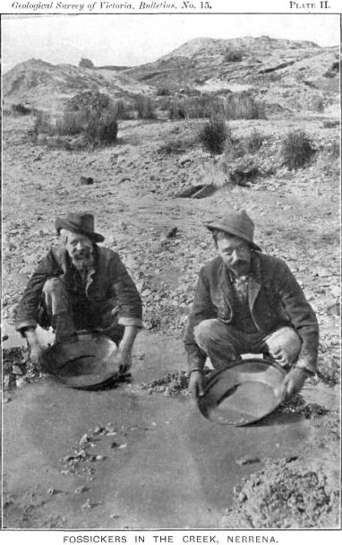
3. What do the details of the image suggest about people who panned for gold?

The Americans who populated the Western frontier—settlers, miners, outlaws, and others—enjoyed various forms of entertainment. Gambling was among the most popular. As a result, western local color writers tended to write about card games, horse races, and other events that featured betting or risk-taking.
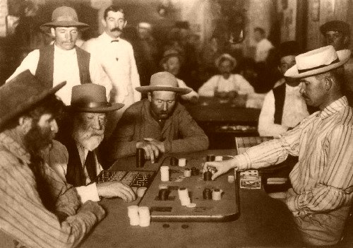
4. What do the types of entertainment shown in the images suggest about the settlers of the Western frontier?

In the 1800s, many Americans were swept up in a religious reform movement called Revivalism. The message that everyone can attain salvation was repeated at countless camp meetings. Many of these were held on the Western frontier. They involved passionate sermons delivered in flowery language by preachers who hoped to promote religious conversions.
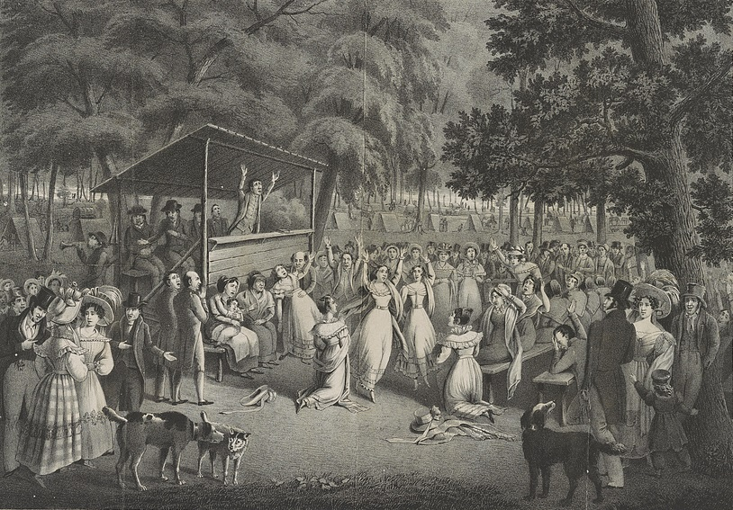
5. What do the details of the scene reveal about frontier camp meetings?

Life on the frontier was not always isolated. Community gatherings focused on the work necessary for survival. Men joined together to help a neighbor raise a new barn. Women worked together at quilting bees. The quilt designs expressed their artistry and craftsmanship. Popular patterns were the Diamond, the Tree of Life, and the Lone Star.
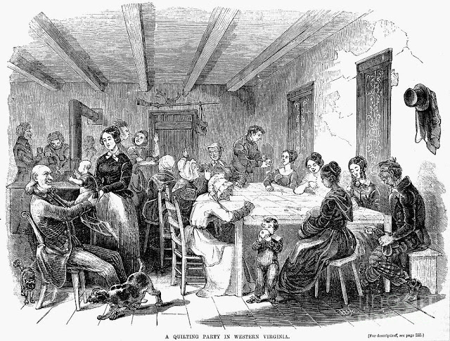
6. What do the details of the image reveal about the lives of frontier women?

Ernest Hemingway, one of the great writers of the 20th century, said that "all modern American literature comes from one book by Mark Twain called Huckleberry Finn."
Twain's voice is something new in American writing. He combines colloquial speech, dialect, and humor with the techniques and themes of classic literature.
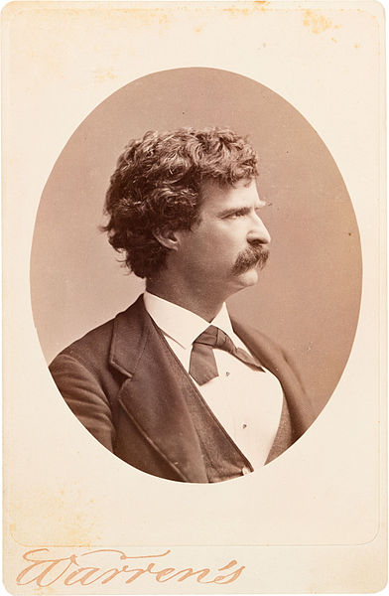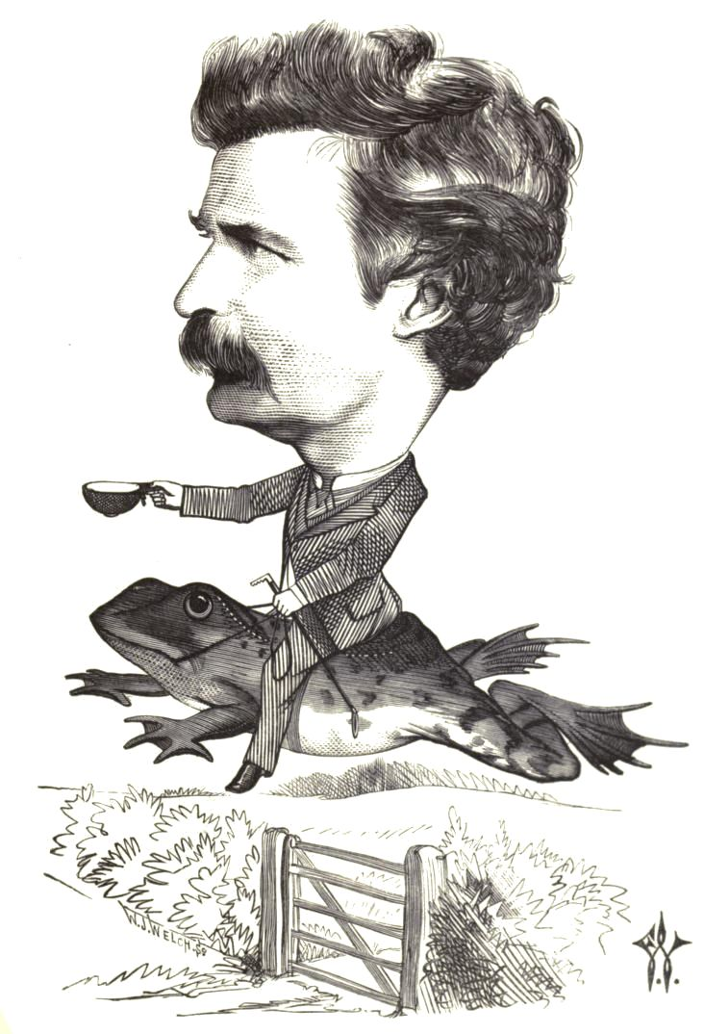
7. What do the images reveal about Mark Twain's personality and sense of humor?

Part B – Respond
As you read the excerpt from Twain’s “The Notorious Jumping Frog of Calaveras County,” list the most important and interesting themes and stylistic devices you find.
Rev. Leonidas W. H'm, Reverend Le—well, there was a feller here once by the name of Jim Smiley, in the winter of '49—or may be it was the spring of '50—I don't recollect exactly, somehow, though what makes me think it was one or the other is because I remember the big flume warn't finished when he first come to the camp; but any way, he was the curiosest man about always betting on anything that turned up you ever see, if he could get anybody to bet on the other side; and if he couldn't he'd change sides. Any way that suited the other man would suit him—any way just so's he got a bet, he was satisfied. But still, he was lucky, uncommon lucky; he most always come out winner. He was always ready and laying for a chance; there couldn't be no solit'ry thing mentioned but that feller'd offer to bet on it, and take ary side you please, as I was just telling you. If there was a horse-race, you find him flush or you'd find him busted at the end of it; if there was a dog-fight, he'd bet on it; if there was a cat-fight, he'd bet on it; if there was a chicken-fight, he'd bet on it; why, if there was two birds setting on a fence, he would bet you which one would fly first; or if there was a camp-meeting, he would be there reg'lar to bet on Parson Walker, which he judged to be the best exhorter about here, and so he was too, and a good man. If he even see a straddle-bug start to go anywheres, he would bet you how long it would take him to get to—to wherever he was going to, and if you took him up, he would foller that straddle-bug to Mexico but what he would find out where he was bound for and how long he was on the road. Lots of the boys here has seen that Smiley and can tell you about him. Why, it never made no difference to him—he'd bet on any thing—the dangdest feller. Parson Walker's wife laid very sick, once, for a good while, and it seemed as if they warn't going to save her; but one morning he come in, and Smiley up and asked him how she was, and he said she was considerable better—thank the Lord for his inf'nite mercy—and coming on so smart that with the blessing of Prov'dence she'd get well yet; and Smiley, before he thought says, "Well, I'll resk two-and-a-half that she don't anyway."

Themes | Stylistic Devices and Textual Evidence
1. Luck isn’t always on a person’s side. | 1. 1st Person Point of View—“I don’t recollect exactly, somehow, though what makes me think…”
2. | 2.
3. | 3.
4. | 4.
5. | 5.

Part C - Analysis

Identify and interpret the major stylistic devices. An excellent analysis will address many but not necessarily all of the following:

- Literary genre in which the excerpt is written
- Diction, dialect, and colloquial language
- Syntax
- Speaker's point of view, attitude, and tone
- Use of figurative language

In one paragraph, explain one of your chosen themes using textual evidence for support and clarification.
Type your paragraph in the space below.

