Example of a Poem

“Johnny‘s eyes glowed. Dally was proud of him. That was all Johnny had ever wanted. Ponyboy. . . . Stay gold, Ponyboy. Stay gold . . .‘ The pillow seemed to sink a little, and Johnny died.” (page 148)

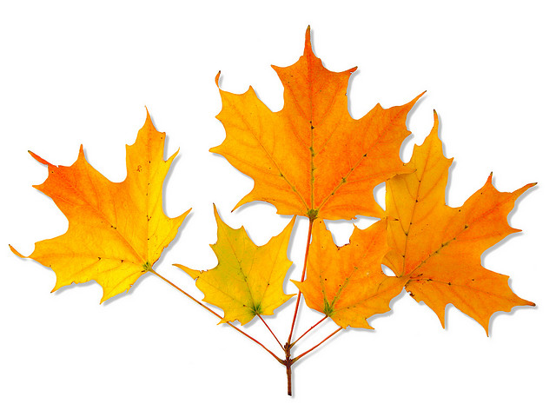

Nothing Gold Can Stay

Nature's first green is gold,

Her hardest hue to hold.

Her early leaf's a flower;

But only so an hour.

Then leaf subsides to leaf.

So Eden sank to grief,

So dawn goes down to day.

Nothing gold can stay.

Robert Frost, 1923