Steinbeck’s “Paradox and Dream”

1. [paradox](http://www.thefreedictionary.com/paradox)

Definition: a statement that seems to contradict itself but may nonetheless be true

Sentence: Pardon the seeming *paradox*; I mean what I say.

Picture: 

2. [bridle](http://www.thefreedictionary.com/bridle)

Definition: to be angry or resentful; take offense

Sentence: Road rage was apparent when the *bridle* man blew his horn longer than was necessary. Picture: 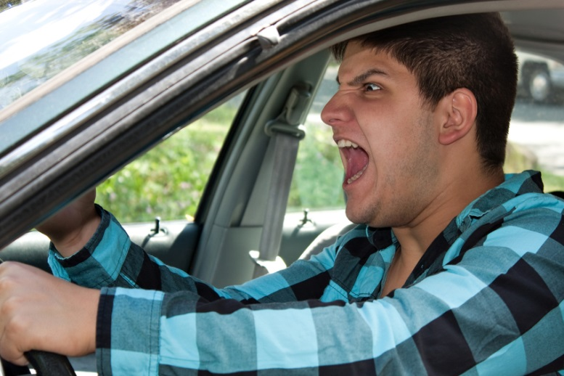

3. [intemperate](http://www.thefreedictionary.com/intemperate)

Definition: having or showing a lack of self-control

Sentence: The *intemperate* toddler picked up the scissors and cut his own hair.

Picture: 

4. [benign](http://www.thefreedictionary.com/benign)

Definition: not harmful

Sentence: The mole on Barbara’s back was *benign*; therefore, she didn’t need to get it removed.

Picture: 

5. [highbrow](http://www.thefreedictionary.com/highbrow)

Definition: a person who has superior intellectual or cultural interests and tastes

Sentence: The *highbrow* audience stood to their feet after the montage of classical singers and musicians ended the show.

Picture: 