Mark Twain’s “The Celebrated Jumping Frog of Calaveras County” Vocabulary

1. [garruluos](http://www.thefreedictionary.com/garrulous)

Definition: talkative; excessive rambling

Sentence: The *garrulous* students received detention for their excessive talking.

Picture: 

2. [append](http://www.thefreedictionary.com/append)

Definition: to attach or affix; add as a supplement or appendix

Sentence: The peanut butter *appended* the birdseed to the birdfeeder that we hung outside.

Picture: 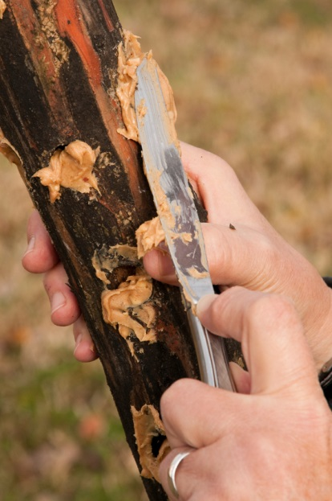

3. [conjecture](http://www.thefreedictionary.com/conjecture)

Definition: to guess or opinion based on incomplete evidence

Sentence: Caroline made a *conjecture* on how many jellybeans were in the jar.

Picture: 

4. [dilapidated](http://www.thefreedictionary.com/dilapidated)

Definition: falling to pieces or into disrepair

Sentence: The *dilapidated* house had trees growing inside of it because no one had lived there in thirty years.

Picture: 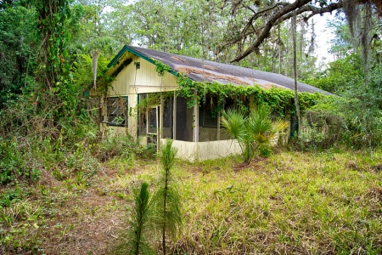

5. [interminable](http://www.thefreedictionary.com/interminable)

Definition: without an end; endless

Sentence: The horizon looks *interminable* as I gaze out into the ocean.

Picture: 

6. [exhorter](http://www.thefreedictionary.com/exhorter)

Definition: one who urges or gives advice or warning

Sentence: Mrs. Cunningham, the school guidance counselor, is an *exhorter* to all students encouraging us to keep up our grades.

Picture: 

7. [cavorting](http://www.thefreedictionary.com/cavorting)

Definition: prancing around; having lively fun

Sentence: The kindergarten children were *cavorting* around the playground by their second week of school excited to see their newly made friends.

Picture: 

8. [vagabond](http://www.thefreedictionary.com/vagabond)

Definition: someone who wanders from place to place, having no visible means of support

Sentence: Little Johnny said he was going to run away and be a *vagabond* taking the train from town to town.

Picture: 

9. [afflicted](http://www.thefreedictionary.com/afflicted)

Definition: suffering from an illness or other painful physical condition

Sentence: Roscoe has to go to the vet because he is *afflicted* with a cold.

Picture: 