Name:

Date:

School:

Facilitator:

6.04 AS-AD Model

Total Points: 48

**This assignment examines the short run changes in Aggregate Demand and Aggregate Supply. Complete the chart below by answering the following questions. Highlight the hints for each column before completing the chart.**

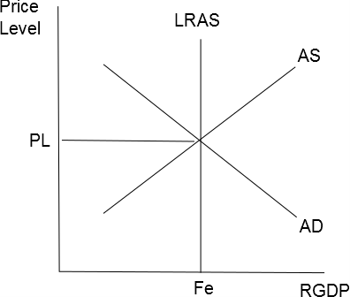

* **Which curve shifts? AD or AS?** 
  + Answer “AD” if spending changed by any of the components of AD, namely by C, I, G, or Xn.
  + Answer “AS” if producers/suppliers have been affected by government programs such as taxes or subsidies, technology, costs of inputs, or productivity.
* **Which direction? Left or Right?** 
  + Answer “shifts right” if more spending or production has occurred.
  + Answer “shifts left” if less spending or production has occurred.
  + Memory aid: More right, Left less.
* **PL and GDP Output Changes? Increase or Decrease?**
  + Step 1. Draw a graph for each scenario in your notebook.
  + Step 2: Circle your equilibrium intersection.
  + Step 3: Shift the correct curve and direction you have already answered.
  + Step 4: Circle the new equilibrium point.
  + Step 5: Read your graph. What happened? Did PL increase or decrease? Did GDP Output increase or decrease?

| **Situation** | **Which curve shifts – AD or AS?** | **Which direction – left or right?** | **Does price level increase or decrease?** | **Does real GDP output increase or decrease?** |
| --- | --- | --- | --- | --- |
| ***Example:*** *New NASA program to Mars* | *AD* | *Right* | *Increase* | *Increase* |
| 1. The government increases spending sharply on infrastructure |  |  |  |  |
| 1. American goods are too expensive for foreign buyers (Tough question!) |  |  |  |  |
| 1. Farmers use GPS to plant seeds more efficiently |  |  |  |  |
| 1. With renewed confidence, consumers increase spending for Christmas/winter holidays |  |  |  |  |
| 1. The government increases regulations on greenhouse gas emissions |  |  |  |  |
| 1. The government cuts research and development programs at universities |  |  |  |  |