Name:
Date:
School:
Facilitator:

6.01 Tools of the Federal Reserve
Total Points: 48
Complete all five parts of this assignment.

Part 1: Matching
Match the terms on the left with their definitions.

- Reserve Requirement

- Discount Rate

- Open Market Operations

- Federal Funds Rate

A. The rate that member banks charge each other for overnight loans.
B. The daily buying and selling of government securities by the New York Federal Reserve Bank.
C. The amount of money the Federal Reserve Bank charges members for loans from directly from the fed.
D. The amount of money the Federal Reserve requires member banks to keep on hand. Traditionally this number has been kept around 10 percent.

Part 2: Rates
To answer the following questions:
- Go to the Federal Reserve System (search tool) linked on the Task page.
- Click on the Data tab.
- Go to Selected Interest Rates.

- What is the current Discount Rate (window)?

- What is the current Federal Funds Rate?

Part 3: Tools
Use what you’ve learned in the lesson to answer the following questions.
- What tool is conducted by the New York Federal Reserve Bank?

- Which tool is used daily by the Federal Reserve?

- Which tool changes the least? (The last time it changed was 1992.)

Part 4: You’re the Chair
Pretend you are the Chairperson of the FED and must conduct Monetary Policy to help cure the following two groups of economic ailments affecting the economy.
To answer the following questions, use the terms Raise, Lower, Increase, Decrease, Buy, Sell, Expansionary, or Contractionary correctly. You may use the terms more than once.

Recession, Unemployment, Slow Growth in GDP
- You will conduct monetary policy. To do this, you will direct that the following tools will:
  - the reserve requirement
  - the discount rate
  - the federal funds rate
  - the bonds and securities
  - the money supply
  - the interest rate

Inflation
- You will conduct monetary policy. To do this, you will direct that the following tools will:
  - the reserve requirement
  - the discount rate
  - the federal funds rate
  - the bonds and securities
  - the money supply
  - the interest rate

Part 5: Graphs
Look at the following two graphs. Sm is the supply of money.
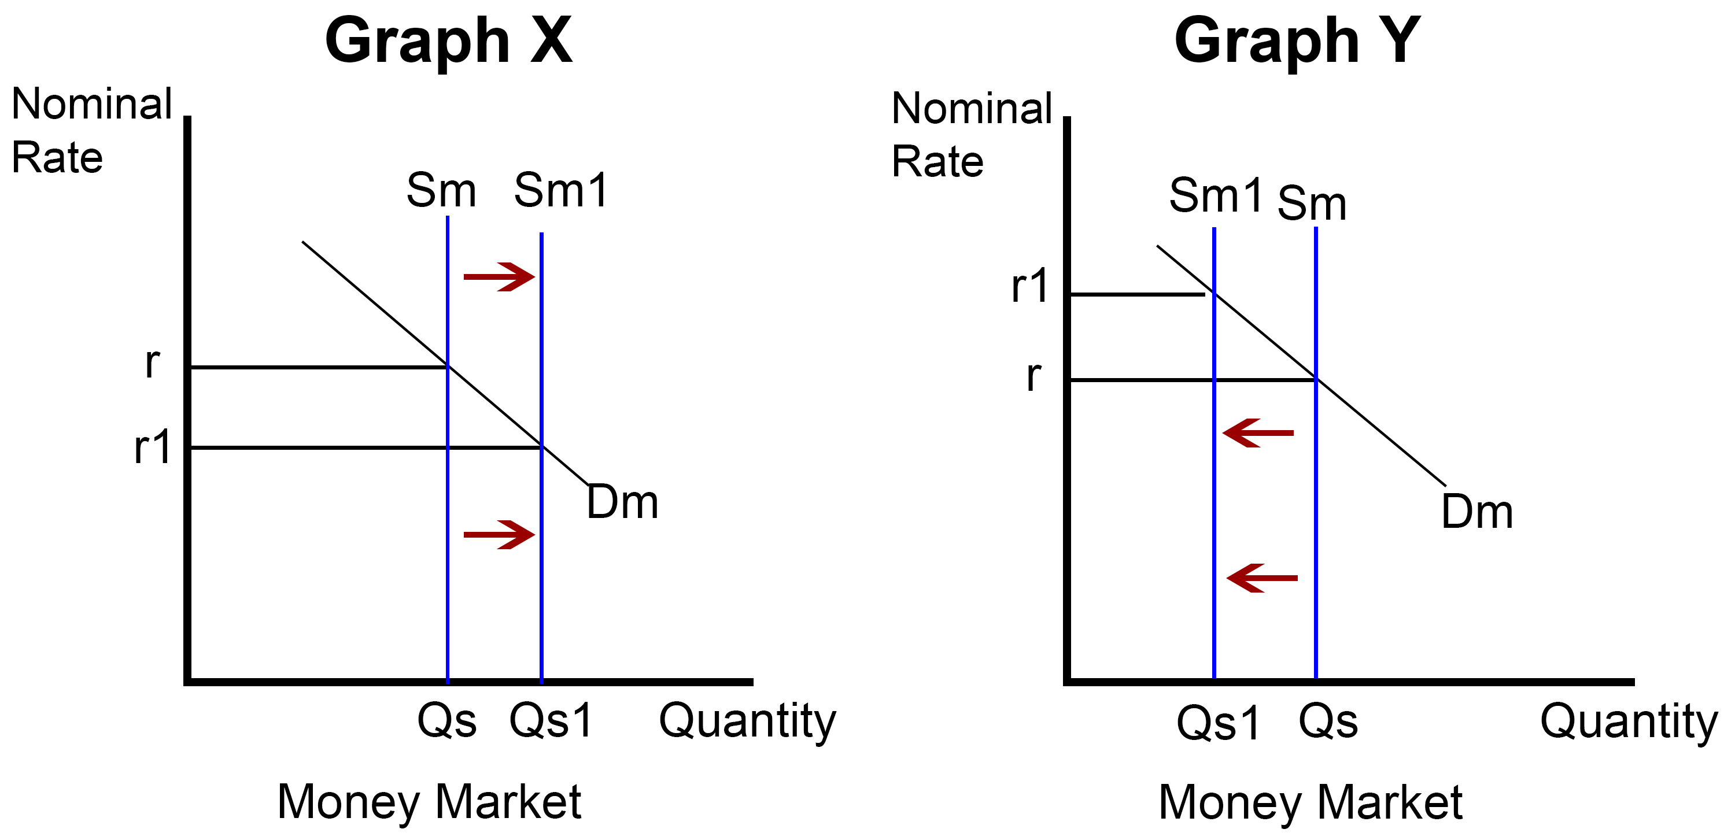
See larger version of graphs here.

- Which of the two graphs depicts a contractionary monetary policy resulting in an increase in interest rates?

- Which of the two graphs depicts an expansionary monetary policy resulting in a decrease in interest rates?

