Name:
Date:
School:
Facilitator:

3.06 Market Equilibrium
Total Points: 48
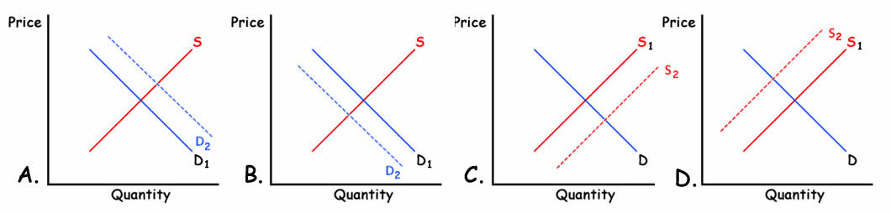
Complete this activity in the table beginning on the next page.
- Determine how the market for the product in Column 1 is affected by the event in Column 2.
- Follow the five examples provided to you to complete column 3 as shown. Your answer choices for Column 3 are one of the following letters: T, R, I, B, E, R, O, T, T, E, N.
- For column 4, select the correct supply and demand graph above (A, B, C, or D) for each of the situations listed in the table.
- For each situation, assume that supply and demand are in a state of equilibrium to start.

Product | Event | What non-price determinant is causing the curve to shift? Choose the specific letter in the correct acronym.  Hint: TRIBE affects demand and ROTTEN affects supply. | Answer
Example: Oranges | A drought destroys half of the crop. | Supply is affected so choose ROTTEN. Answer is R for resource costs have increased. | D
- Fast Food Restaurants | The minimum wage is raised to $15.
- T-bone Steaks | Personal Income Tax rate reduction. | Demand is affected so choose TRIBE. Answer is I for income has increased.
- Movie Popcorn | The price of movie tickets increases.
- Disney World hotels | Disney World increases ticket prices.
- New Housing Construction | The cost of lumber decreases. | Supply is affected so choose ROTTEN. Answer is R for resource costs have decreased.
- Pepsi | The price of Coca Cola increases.
- Firewood | Your local TV weather reporter says “Snow is likely.”
- Normal Goods | People receive a 20% pay increase.
- Inferior Goods | People receive a 20% pay increase. | Demand is affected so choose TRIBE. Answer is R for related products (substitutes) expectations.
- Samsung Galaxy phones | Apple iPhone 6 lowers its prices.
- Light bulbs | The government places a tax on light bulb filaments.
- Any business | A wave of optimism sweeps the country causing everyone to whistle why they work. | Demand is affected so choose TRIBE. Answer is E for expectations.
- Fireworks | The government subsidizes the production of fireworks.
- Soybeans | A new tractor is invented that cuts harvesting time in half.

