Name:

Date:

Facilitator:

School:

7.03 International Trade

Use the following to chart to answer the questions below about international trade.

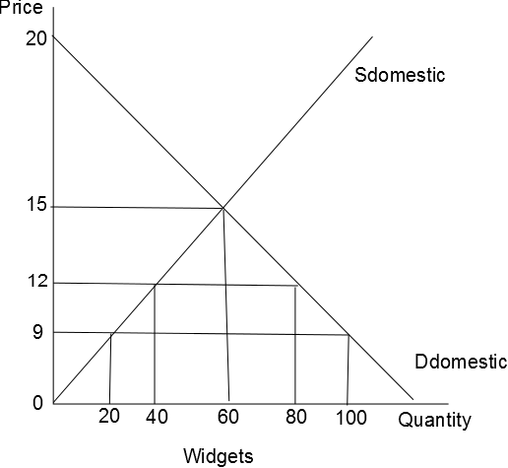

**Assume that the world price for widgets is $9.**

1. If the government places a $3 tariff on all foreign produced widgets, the total domestic production will be       .

2. The total number of imported widgets with a $3 tariff will be       .

3. How much revenue will a foreign producer make if there is no tariff or quota?       .

4. The value of consumer surplus with free world trade would be       and the value of consumer surplus in a closed economy would be       .

5. The value of producer surplus with free world trade would be      , and the value of producer surplus in a closed economy would be       .

6. With a $3 tariff the government would make       in tax revenue.

7. In a closed economy the equilibrium price would be       and the equilibrium quantity would be       .

8. A tariff will increase the income of which producers?

9. If a tariff was removed we would expect what to happen to the equilibrium price?

10. A tariff is meant to reduce the amount of competition for which group?

11. Will domestic production be greater in a closed or open economy?

12. Will equilibrium price be smaller in a closed or open economy?

13. What are some of the advantages of free trade?

14. What are some of the disadvantages of free trade?