Name:
Date:
Facilitator:
School:
7.03 International Trade
Use the following to chart to answer the questions below about international trade.
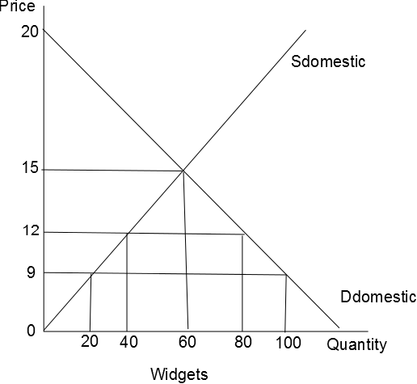
Assume that the world price for widgets is $9.
1. If the government places a $3 tariff on all foreign produced widgets, the total domestic production will be .
2. The total number of imported widgets with a $3 tariff will be .
3. How much revenue will a foreign producer make if there is no tariff or quota? .
4. The value of consumer surplus with free world trade would be and the value of consumer surplus in a closed economy would be .
5. The value of producer surplus with free world trade would be , and the value of producer surplus in a closed economy would be .
6. With a $3 tariff the government would make in tax revenue.
7. In a closed economy the equilibrium price would be and the equilibrium quantity would be .
8. A tariff will increase the income of which producers?
9. If a tariff was removed we would expect what to happen to the equilibrium price?
10. A tariff is meant to reduce the amount of competition for which group?
11. Will domestic production be greater in a closed or open economy?
12. Will equilibrium price be smaller in a closed or open economy?
13. What are some of the advantages of free trade?
14. What are some of the disadvantages of free trade?

