Name:
Date:
Facilitator:
School:
7.01 Charting Comparative Advantage
Using the graph below to answer questions 1-10.
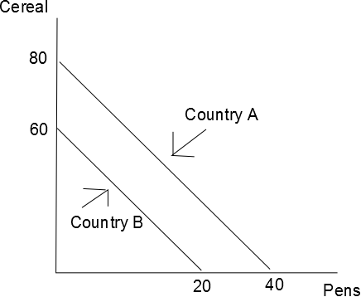
1. Who has the absolute advantage in cereal?
2. Who has the absolute advantage in pens?
3. What is the opportunity cost for Country A producing 1 cereal?
4. What is the opportunity cost for Country A producing 1 pen?
5. What is the opportunity cost for Country B producing 1 cereal?
6. What is the opportunity cost for Country B producing 1 pen?
7. Who has the comparative advantage in producing cereal?
8. Who has the comparative advantage in producing pens?
9. If the terms of trade is 1 pen for 2 ½ cereals, should the nations trade? Explain.
10. If both nations specialize and trade according to comparative advantage, draw their new production possibilities frontier and show the change. Use the graphs below as a base. You may use Word drawing tools for your curves or draw your graphs on paper and insert the labeled pictures.

Using the table below to answer questions 11-19.
 | Peanuts | Bats
Country Y | 15 | 60
Country Z | 10 | 80

11. Who has the absolute advantage in peanuts?
12. Who has the absolute advantage in bats?
13. What is the opportunity cost for Country Y producing 1 peanut?
14. What is the opportunity cost for Country Y producing 1 bat?
15. What is the opportunity cost for Country Z producing 1 peanut?
16. What is the opportunity cost for Country Z producing 1 bat?
17. Who has the comparative advantage in producing peanuts?
18. Who has the comparative advantage in producing bats?
19. If the terms of trade are 1 peanut for 9 bats, should the nations trade? Explain.

