Name:

Date:

Facilitator:

School:

6.02 AS-AD Model

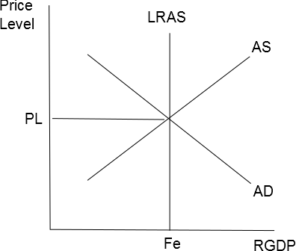

**For each given situation, explain what will happen to *price level* and *output*. Depending on the shift of the curve, will the country be in a *recessionary* or *inflationary gap*? Start each scenario in long run equilibrium**.

| **Situation** | **Which curve shifts?**  **Which direction?** | **Price Level and Output**  **Increase or Decrease** |
| --- | --- | --- |
| The cost of oil rises sharply | AS to the left | Price level increases  Output decreases |
| 1. The Government increases spending sharply on infrastructure |  |  |
| 1. American goods increase in demand from foreign buyers |  |  |
| 1. Immigration into the country increases dramatically |  |  |
| 1. Interest rates decrease |  |  |
| 1. A technological breakthrough makes companies more productive |  |  |
| 1. The government increases regulations on greenhouse gas emissions |  |  |
| 1. The government increases subsidies in all sectors of the economy |  |  |
| 1. With renewed confidence   consumers increase spending for Christmas |  |  |