Name:      Facilitator:

Date:       School:

3.06 Market Equilibrium

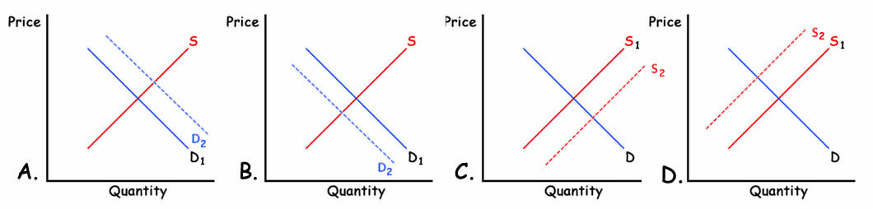

Indicate which graph best describes the scenario. Use determinants of demand and determinants of supply (INSECT or PESTSTRIP) to support your answers.

|  |  |  |
| --- | --- | --- |
| **Product** | **Related Item** | **Answer** |
| 1. Oranges | A drought destroys half of the crop. |  |
| 1. Fast Food Restaurants | The minimum wage is raised to $15. |  |
| 1. T-bone Steaks | Personal Income Tax rate reduction. |  |
| 1. Movie Popcorn | The price of movie tickets increases. |  |
| 1. Disney World hotels | Disney World increases ticket prices. |  |
| 1. New Housing Construction | The cost of lumber decreases. |  |
| 1. Pepsi | The price of Coca Cola increases. |  |
| 1. Firewood | Your local TV weather reporter says the word “Snow”. |  |
| 1. Normal Goods | People receive a 20% pay increase. |  |
| 1. Inferior Goods | People receive a 20% pay increase. |  |
| 1. Samsung Galaxy | Apple iPhone 6 lowers its prices.  . |  |
| 1. Light bulbs | The government places a tax on light bulb filaments. |  |
| 1. Any business | A wave of optimism sweeps the country causing everyone to whistle why they work. |  |
| 1. Fireworks | The government subsidizes the production of fireworks. |  |
| 1. Soybeans | A new tractor is invented that cuts harvesting time in half. |  |