Name:

Date:

Facilitator:

School:

3.03 Change in Demand

Use the chart below to help you determine the BEST answer to the given scenarios. When reading each scenario you should consider the *item in parenthesis* to determine the best answer.

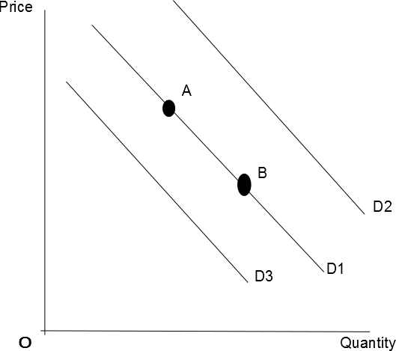

1. A to B
2. B to A
3. D1 to D2
4. D1 to D3
5. No Change
6. The price of iPad Pro tablets is reduced 35%. What will happen to the demand curve for iPad Pro tablets? (iPad Pro tablet)

1. The price of iPad Pro tablets is reduced by 35%. What will happen to the demand curve for Microsoft Surface Pro tablets? (Microsoft Surface Pro tablets)

1. The price of printer cartridges decreases. What will happen to the demand curve for printer cartridges? (printer cartridges)

1. The price of printer cartridges increases dramatically. What will happen to the demand curve for printers? (printers)

1. Apple offers an in-store discount for all new IPad purchases. What will happen to the demand curve for IPads? (IPads)

1. A company has developed a new kind of engine that runs without the use of oil/gasoline. Therefore, most new vehicles and other machinery are now being manufactured using this new “no-oil” engine. What will happen to the demand curve for oil/gasoline? (Oil/gasoline)

1. To help sell oil/gasoline manufactures reduce the price of a barrel of oil by 20%. What will happen to the demand curve for oil/gasoline? (Oil/gasoline)

1. The cost of producing oil/gasoline increases. What will happen to the demand curve for oil/gasoline? (Oil/gasoline)

1. A large tax increase is passed through Congress. This tax increase affects nearly every consumer living in a nation and means that consumers have less money to spend. What will happen to the demand curve for inferior goods? (Inferior Goods)

1. A large tax increase is passed through Congress. This tax increase affects nearly every consumer living in a nation and means that consumers have less money to spend. What will happen to the demand curve for normal goods? (Normal Goods)