Name:

Date:

Facilitator:

School:

6.01 Tools of the Federal Reserve

Matching: Match the terms on the left with their definitions.

|  |  |
| --- | --- |
| Reserve Requirements | **A**. The rate that member banks charge each other for overnight loans. |
| Discount Rate | **B**. The daily buying and selling of government securities by the New York Federal Reserve Bank. |
| Open Market Operations | **C**. The amount of money the Federal Reserve Bank charges members for loans from directly from the fed. |
| Federal Funds Rate | **D**. The amount of money the Federal Reserve requires member banks to keep on hand. Traditionally this number has been kept around 10 percent. |

Use the website [www.federalreserve.gov](http://www.federalreserve.gov) to answer the following questions.

5. What is the current Discount Rate?

6. What is the current Federal Funds Rate?

7. Which tool is used more as a signal than an actual tool?

8. Which tool is used most often by the Federal Reserve?

9. Which tool changes the least?

10. Which tool does the Federal Reserve believe is the key rate in determining the money supply?

Use each of the terms listed below to identify how the Federal Reserve accomplishes each policy.

BUY, SELL, RAISE, LOWER

Expansionary Policy is increasing the money supply, or sometimes called “loose money”.

Contractionary Policy is decreasing the money supply, or sometimes called “tight money”.

11. Expansionary

      securities

      the discount rate

      the reserve requirement

12. Contractionary

      securities

      the discount rate

      the reserve requirement

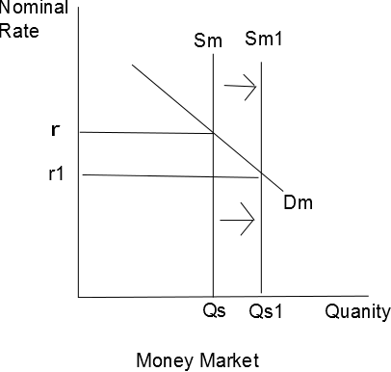 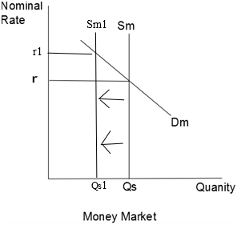

13. With an expansionary policy, the supply of money       , which causes the interest rate to       .

14. With a contractionary policy, the supply of money       , which causes the interest rate to       .