Name:

Date:

Facilitator:

School:

9.05 Historical Fiction Short Story

Directions: Write a historical fiction short story with an interesting plot and well-developed characters. Remember to incorporate the steps in plot.

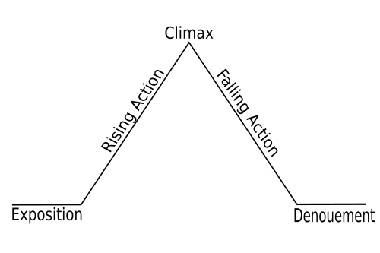

* To keep your readers interested in the situation, characters, and setting, something has to happen. The sequence of events, or plot, should move the story.
* Let the characters reveal themselves through indirect characterization.

Write your story below the line.

………………………………………………………………………………………………………………