Name:

Date:

Facilitator:

School:

3.05 Short Story

Directions: Write a short story with an interesting plot and well-developed characters. Now, identify a problem or conflict that your character will need to resolve. Then, further develop the plot in your story and choose a point of view to suit it.

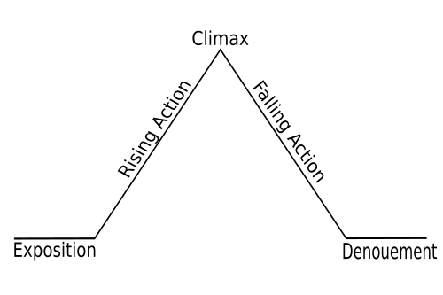

* To keep your readers interested in the situation, characters, and setting, something has to happen. The sequence of events, or plot, should move the story.
* Think about the questions below as you go.

1. What is the conflict?

2. What happens next?

3. Will things go on like this forever?

4. What happens to the characters in the end?

* Let the characters reveal themselves through indirect characterization.

Write your story below the line.

………………………………………………………………………………………………………………