Name:
Date:
Facilitator:
School:

2.05 Genre
Part A

Directions: Choose five different genres from the box below.

nonfiction, historical fiction, science fiction, realistic fiction, poetry, fairytale, fable, tall tale, myth, drama, biography, autobiography

Next, write in the genre you choose. You should write about a half page for each.

Example:
Genre: Tall Tale
There once was a little boy who was so set on not going to bed that he set an alarm for every half an hour just to make sure he didn’t fall asleep. He tried to tell his parents that it was educational staying up all night. He may miss the monster coming out from underneath his bed, or he may sleep through Santa Claus bringing him toys. One night the little boy’s parents decided not to check on their son. They told him he could stay up all night. The next morning, the parents found a note left by the monster under his bed. The little boy had gone on a field trip.
Genre 1:

Genre 2:

Genre 3:

Genre 4:

Genre 5:

Part B

Directions: Choose one genre from the box below.

historical fiction, science fiction, realistic fiction, biography, autobiography, fairy tale, fable, tall tale

You will create a “movie poster” for the selected genre. The information may be accurate or imagined.
- The genre and subgenre should be at the top
- The title of the movie comes next
- Include an appropriate picture that shows the subgenre of the movie
- Explain why this movie belongs in the subgenre you’ve described.
- Write who your staring actors/actresses will be (actors/musicians or people you know)

Example:
- Genre and subgenre  - Title  3. Full color (or carefully sketched) illustration  4. Why the story belongs in the subgenre listed  5. At least two actors and/or actresses | Genre: Fiction Subgenre: Science Fiction  Aliens from Outer Space!  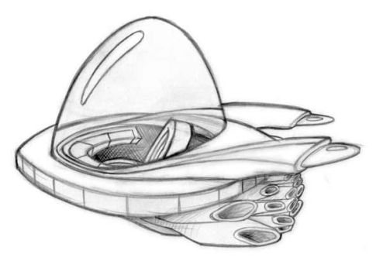  Aliens from Outer Space is science fiction. I know this because the story has aliens and advanced technology.  Starring:  Tim O’Hara as Max Powers  Justin Bieber as the Martian

Genre: Subgenre:

Title:

Picture:

Explanation:

Starring:

