Name:
Date:
Facilitator:
School:

2.04 Figurative Language
Part A
Directions: Complete the chart below by providing original examples of figurative language. Choose an image that helps you visualize the figure of speech. Use the figure of speech in an creative sentence, and then explain what the sentence is actually saying.
Animal | Figure of Speech |  | Image | Sentence | Explanation
1. bear | Example | Simile / Idiom | 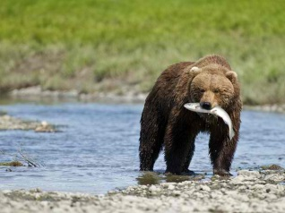 | Jack was as hungry as a bear preparing for winter. | Jack is being compared to a hungry bear because he is really hungry.
1. spider
2. roadrunner
3. turtle
4.Your choice
5. Your choice

Part B
Directions: Choose one of your examples from the chart and write about it. Include each of the following types of figurative language: simile or metaphor, personification, alliteration, hyperbole or understatement, onomatopoeia, idiom or oxymoron. Highlight each example of figurative language in the appropriate color.

