Name:

Date:

Facilitator:

School:

2.02 Metaphors and Similes

**Part A**

Directions: Read the similes below; then create a better, more concrete simile.

Explanation: You may have heard of someone who was *old as dirt*. That is a simile, but it isn’t very specific. How old is that dirt? Where did the dirt come from? *You are as old as the dirt under a stegosaurus’s nails.*

1. quiet as a mouse

Revision:

2. still as a rock

Revision:

3. love is like a rose

Revision:

4. fought like cats and dogs

Revision:      

5. cold as ice

Revision:

**Part B**

Directions: Look at the pictures below; then create an original sentence using a simile or metaphor.

6. 

Original Sentence:

7. 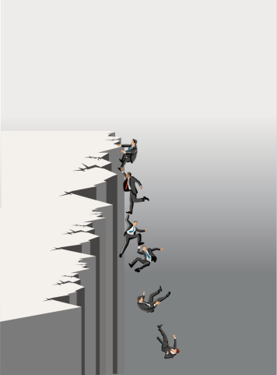

Original Sentence:

8. 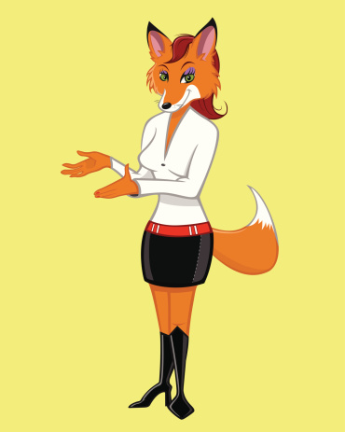

Original Sentence:

9. 

Original Sentence:

10. 

Original Sentence:

**Part C**

Directions: Read [“Some Days”](https://www.poets.org/poetsorg/poem/some-days) by Billy Collins. Then, create a poem, story, or essay comparing your life to something else. Make sure you give your work a title.

Start writing below this line:

__________________________________________________________________________________