5.05 AutoSum

Total Points: 30

# ****In This Task****

In this task, we will utilize the worksheet you used in the previous lesson to create functions. You are going to modify the spreadsheet by inserting new columns, and you will be able to see how the formulas adjust to reflect the new column cell reference names.

Instead of keying the formulas like we did in the previous lesson, you will use the AutoSum button to help you create the formula functions. This feature will help you simplify creating your worksheet. Spreadsheets offers many features like these to help make creating worksheets easy.

You will still be using the following functions, but remember, you are going to use the AutoSum button:

* SUM — to total a range of cells
* AVERAGE— to average a range of cells
* COUNT— to determine how many items are in a column or row
* MAX — to determine the largest number in a row or column
* MIN — to determine the smallest number in a row or column

Open the spreadsheet you used in the lesson 5.04 task and follow the instructions below to modify it further.

# Part 1: Modifying the Worksheet

1. Click on the **F** in the shaded area at the top of the spreadsheet. This should cause the entire **column** to become highlighted.
2. Click on the **Home** tab and find the section labeled **Cells**, then click on the arrow beside the word **Insert,** and then select **Insert Sheet Columns. Do this 3 times so you will have three new columns.** (Spreadsheet should look like this.)

|  | **A** | **B** | **C** | **D** | **E** | **F** | **G** | **H** | **I** | **J** | **K** | **L** | **M** |
| --- | --- | --- | --- | --- | --- | --- | --- | --- | --- | --- | --- | --- | --- |
| **1** | **Student** | **Test 1** | **Test 2** | **Test 3** | **Test 4** |  |  |  | **Total** | **AVG** | **Count** | **MAX** | **MIN** |
| **2** | Joe Smith | 80 | 100 | 93 | 89 |  |  |  | 362 | 90.50 | 4 | 100 | 80 |
| **3** | Ann Thomas | 92 | 85 | 89 |  |  |  |  | 266 | 88.67 | 3 | 92 | 85 |
| **4** | Frank Hardy | 95 | 90 | 88 | 91 |  |  |  | 364 | 91.00 | 4 | 95 | 88 |
| **5** | Mary Sims | 76 |  | 90 | 89 |  |  |  | 255 | 85.00 | 3 | 90 | 76 |
| **6** | Mike Wison | 74 | 90 | 89 | 90 |  |  |  | 343 | 85.75 | 4 | 90 | 74 |
| **7** | **Total** | 417 | 365 | 449 | 359 |  |  |  |  |  |  |  |  |
| **8** | **AVG** | 83.40 | 91.25 | 89.80 | 89.75 |  |  |  |  |  |  |  |  |
| **9** | **Count** | 5 | 4 | 5 | 4 |  |  |  |  |  |  |  |  |
| **10** | **MAX** | 95 | 100 | 93 | 91 |  |  |  |  |  |  |  |  |
| **11** | **MIN** | 74 | 85 | 88 | 89 |  |  |  |  |  |  |  |  |

1. At the top of the spreadsheet, highlight your column headings **Test 3, and Test 4.**

1. Move your mouse to the bottom right corner of the cell that contains the word Test 4 in it. There should be a black square in that corner and as your mouse hovers over it, it will turn into a plus sign.

1. Hold down your left mouse button and move your mouse to the right over the three new columns that you inserted. You should notice that a box will populate showing the words Test 5, Test 6, and Test 7.
2. Release the mouse button and the words populate in the cells. The black square in the bottom right corner of an active cell is called the **fill handle**. This button allows you to copy the formatting in a cell and extend a series such as the Test. It also works for dates, months of the year, and a number series.
3. Enter the following scores below the correct test for the new columns. Do not type F, G, OR H. That information refers to the name of the column where the new columns were inserted.

|  | **F** | **G** | **H** |
| --- | --- | --- | --- |
| **1** | **Test 5** | **Test 6** | **Test 7** |
| **2** | 70 | 95 | 100 |
| **3** | 65 | 92 | 69 |
| **4** | 90 | 98 | 78 |
| **5** | 87 | 90 | 94 |
| **6** | 74 | 90 |  |

1. This is how the spreadsheet should look after the information has been entered.

*\*Note: Before your work will match the picture, you must change the functions in Columns I - M because the functions in will not include the added cells.*

|  | **A** | **B** | **C** | **D** | **E** | **F** | **G** | **H** | **I** | **J** | **K** | **L** | **M** |
| --- | --- | --- | --- | --- | --- | --- | --- | --- | --- | --- | --- | --- | --- |
| **1** | **Student** | **Test 1** | **Test 2** | **Test 3** | **Test 4** | **Test 5** | **Test 6** | **Test 7** | **Total** | **AVG** | **Count** | **MAX** | **MIN** |
| **2** | Joe Smith | 80 | 100 | 93 | 89 | 70 | 95 | 100 | 627 | 89.57 | 7 | 100 | 70 |
| **3** | Ann Thomas | 92 | 85 | 89 |  | 65 | 92 | 69 | 492 | 82.00 | 6 | 92 | 65 |
| **4** | Frank Hardy | 95 | 90 | 88 | 91 | 90 | 98 | 78 | 630 | 90.00 | 7 | 98 | 78 |
| **5** | Mary Sims | 76 |  | 90 | 89 | 87 | 90 | 94 | 526 | 87.67 | 6 | 94 | 76 |
| **6** | Mike Wison | 74 | 90 | 89 | 90 | 74 | 90 |  | 507 | 84.50 | 6 | 90 | 74 |
| **7** | **Total** | 417 | 365 | 449 | 359 |  |  |  |  |  |  |  |  |
| **8** | **AVG** | 83.40 | 91.25 | 89.80 | 89.75 |  |  |  |  |  |  |  |  |
| **9** | **Count** | 5 | 4 | 5 | 4 |  |  |  |  |  |  |  |  |
| **10** | **MAX** | 95 | 100 | 93 | 91 |  |  |  |  |  |  |  |  |
| **11** | **MIN** | 74 | 85 | 88 | 89 |  |  |  |  |  |  |  |  |

# Part 2: Creating the AutoSum formula

Now you will create the formulas using the **AutoSum** button **∑** located on the Home tab of the Excel software.

Please follow the steps provided for creating your first formula in cell **F7**.

1. Click on cell F7 to make it active.

1. Find the **AutoSum** button on the **Home** tab in the **Editing** section.

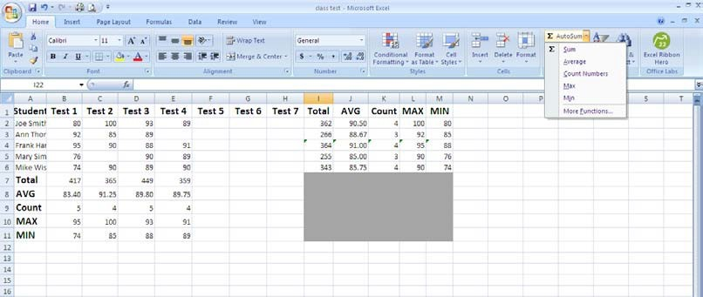

1. Click on the arrow beside the AutoSum button.

1. Select **Sum**.

1. Notice that it creates the sum formula and highlights the cells above F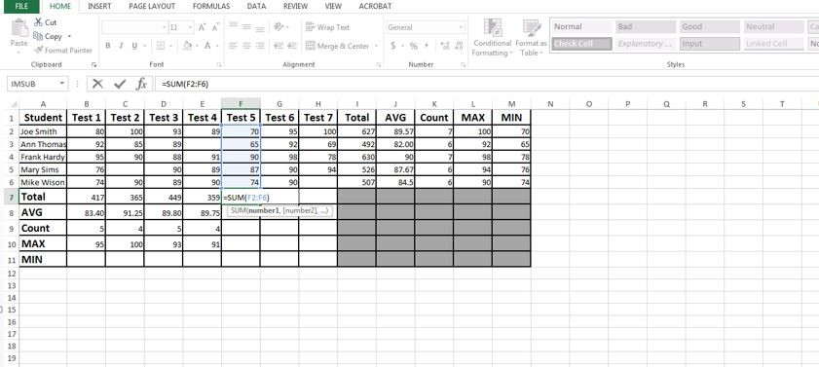
2. Press enter. The formula has been created and you didn’t have to type it!

1. Click on F7 to make it active

1. Move the mouse over the square at the bottom right of cell until it turns into a plus sign.

1. Hold down the left mouse button and move the mouse to the right over cells G7 and H7.

1. Release the mouse button and the formulas are copied over to the cells.

1. Click on G7 to make it active and you will see the formula in the formula bar above the spreadsheet. Notice how the cell names changed to reflect the correct column for that formula. Click on H7 as well to see how the formula changed. Do you remember what this is called? **Relative Cell Reference**

# Part 3: Creating the AutoSum Average formula

Now work on the Average formula for your new columns. Please follow the steps provided for creating the average formula in cell **F8**.

1. Click on cell F8 to make it active.

1. Find the **AutoSum** button on the **Home** tab in the **Editing** section.

1. Click on the arrow beside the AutoSum button.
2. Select Average (instead of sum)

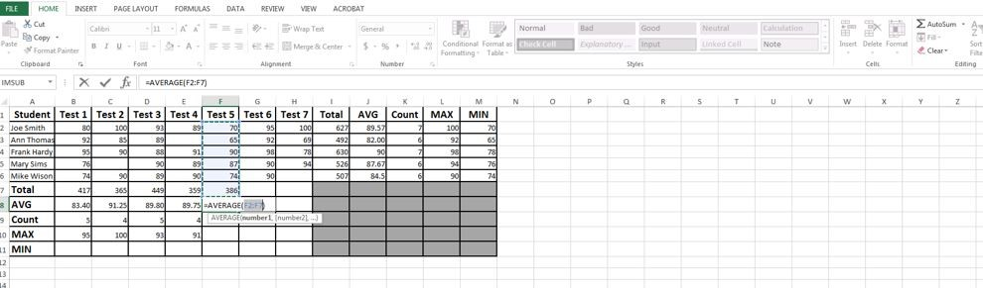

1. Do not press enter yet. You will need to make some adjustments. Notice that the formula includes cell F7. You do not want this cell in your formula because it will make your answer incorrect. To correct the formula, click on cell F2 and highlight through cell F6. This should change the cells in the formula to make it correct. (Note the changes in the formula on the screen shot below)

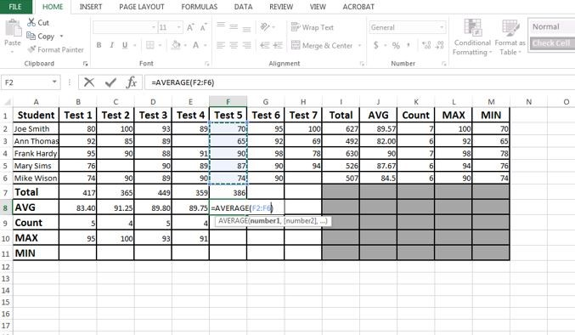

1. Press enter.

1. Use the fill handle to copy the formula across the cells G8 and H8.

# Part 4: Other AutoSum Formulas

To complete the formulas for Count, Min, and Max, follow the above steps changing the formula type to the appropriate selection for each item. Make sure you reselect the cells (Step 5) that you want included in the formula or it will include the cells that contain the formulas in them. Use the fill handle to copy the cells across.

Check the formulas for your rows. These formulas should have changed automatically when you inserted the columns.