Name:
Date:
School:
Facilitator:

5.07 Reading Charts Worksheet
Part 1
Go to http://www.wisc-online.com/objects/index_tj.asp?objID=SOC202 and read the 12 pages to learn more about pie charts. On Page 12, you will see two pie charts about Measuring Company Trust. In the space provided below, type eight conclusions that you can draw when interpreting this chart data. (Instead of emailing instructor in the box provided).
Eight conclusions I can draw are:
1.
2.
3.
4.
5.
6.
7.
8.

Part 2
Look at the example of a bar chart below. There are five models and yellow bars represent speed; blue bars efficiency, and red bars size. See if you can read this chart comparing speed, efficiency, and size for five models:
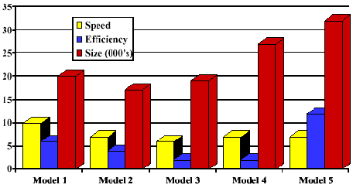
- What is the only model in which efficiency tops speed?
- How much larger is model five then model 3?
- Which model is the slowest?
- What do you suppose models one through 5 might be representing?

Look at the pie chart that follows. See if you can read it and answer Questions 5-8:
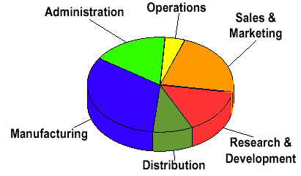
- Which category represents about 25% of all spending?
- Which category represents the largest share of the expenses?
- Which two categories together represent about 50% of all spending?
- How many expense categories are represented by the chart?

