Name:

Date:

School:

Facilitator:

1.09 Charlie Lucas Questions

# Charlie Lucas

**Look at the two pieces of art below by Charlie Lucas and answer the questions based on your knowledge of the elements of art and principles of design. (You might want to open the links on the Task page to see larger versions of these images). Use complete sentences and be sure and provide evidence to your answers.**

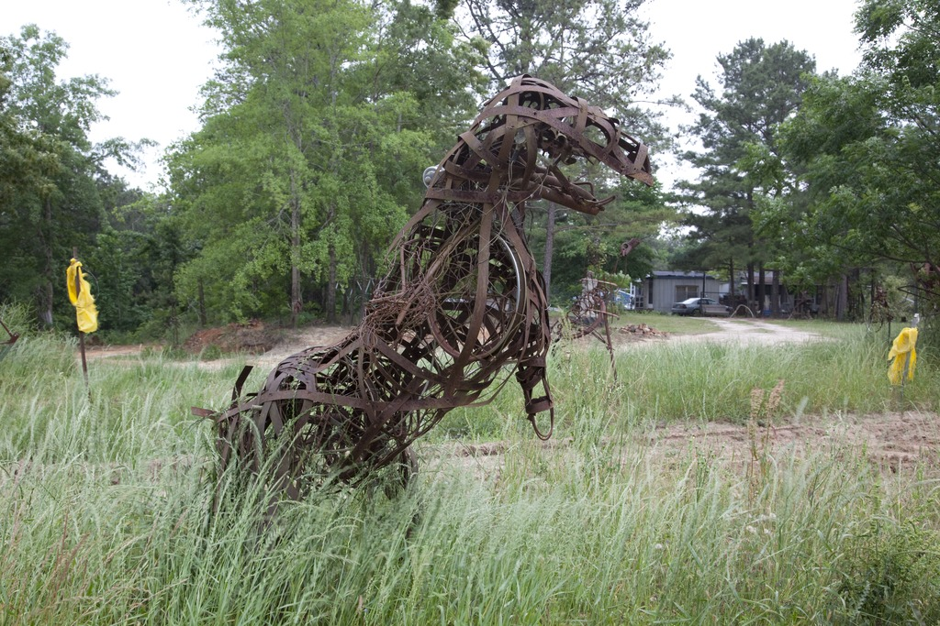 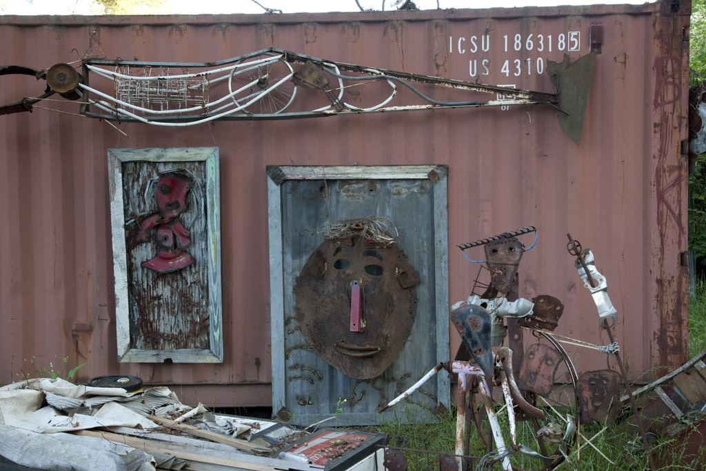

1. Look at Charlie Lucas’s work in the two pictures above. How does he incorporate the **elements of art** in each one? Be sure to explain your answer and provide examples for each artwork.
2. How does Charlie Lucas incorporate the **principles of design** in each of these works of art? Be sure to explain your answer and provide examples for each artwork.

1. Look at both works of art and describe some of the different found objects that Charlie used in each one. What feeling do you get about each piece when you consider the found objects that were used to create them? Be sure to explain your answer and provide examples for each artwork.
2. **Charlie Lucas had a story for each of his “toys.” What story do you think he was telling in each of these works?** Be sure to explain your answer and provide examples for each artwork.
3. **If you had a chance to make something out of found objects like Charlie does, what objects would you use? How would you use them and what story would your creation be telling?** Be sure to explain your answer and provide examples for each artwork.