Name:

Date:

School:

Facilitator:

1.04 Color Wheel

**Label all the colors on the color wheel using the word bank below. For #1-4, identify which are primary, secondary, and intermediate. For #5-16, identify the colors shown on the color wheel and indicate if each color is warm or cool. Refer to the color wheel in the lesson, if needed.**



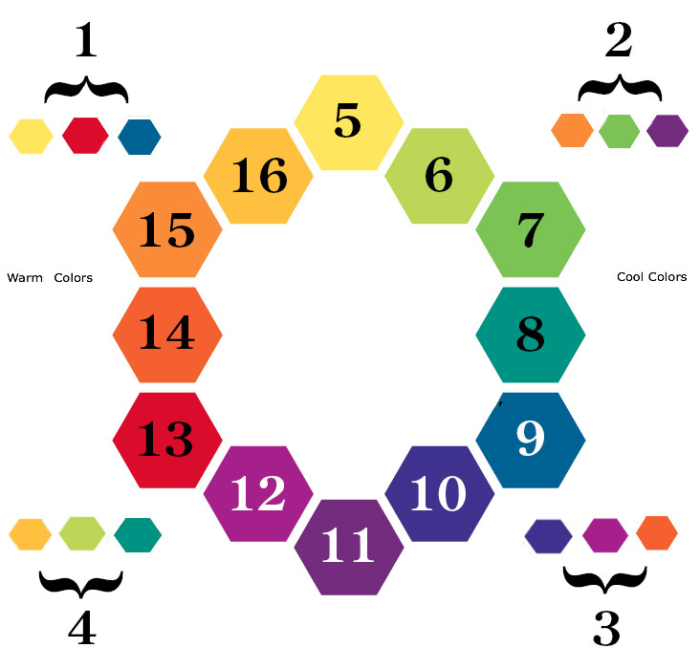

**Word Bank:**

* Blue
* Blue-Green
* Blue-Violet
* Green
* Intermediate Colors
* Intermediate Colors
* Orange
* Primary Colors
* Red
* Red-Orange
* Red-Violet
* Secondary Colors
* Violet
* Yellow
* Yellow-Green
* Yellow-Orange