Name: School:
Date: Facilitator:

6.05 Graph Properties (54 Points)

Hamiltonian and Hamilton Path (12 points)
- In the Hamiltonian graph of G₁, G₂, and G₃, identify a circuit.
Then, identify an edge that can be removed to make the Hamiltonian graph a Hamilton path.
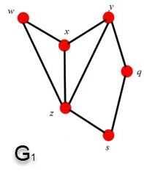 | 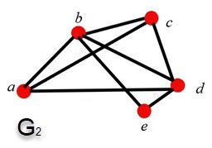 | 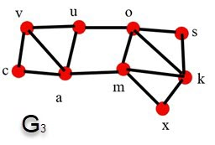

Fill in the table below.
Graphs | Identify a circuit. | Identify an edge that can be removed to become a Hamilton path.
G₁
G₂
G₃

Bipartite Graphs and Hamiltonian (10 points)
- Does the bipartite graph of G₄ has a Hamilton path or is it Hamiltonian?
Explain why it is a Hamilton path or Hamiltonian.

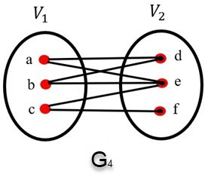
Write your response below:

- Does the bipartite graph of G₅ has a Hamilton path or is it Hamiltonian?
Explain why it is a Hamilton path or Hamiltonian.
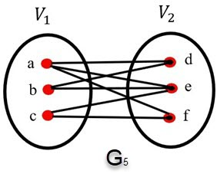

Write your response below:

Hamilton Path, Circuit and Connected Graphs (12 points)
- Look at each graph below.
Which connected paths below have a Hamilton path or circuit?
Find the path or circuit for each graph.

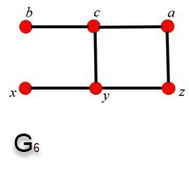 | 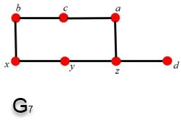 | 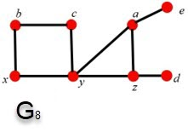

Fill in the table below.
Graphs | Hamilton path, Hamilton circuit, or neither? | List the path or circuit
G₆
G₇
G₈

Tree Graphs (10 points)
- Let $T_{1}=\left(v_{1},e_{1}\right)$ and $T_{2}=\left(v_{2},e_{2}\right)$ be two trees with $e_{1}=11$ and $v_{2}=4v_{1}$.
Find:
- $v_{1},$
- $v_{2},$and
- $e_{2}$.
Remember: $e=v-1$.
Show your work in the space provided below.

Show your work here:

- Let $T_{1}=\left(v_{1},e_{1}\right)$ and $T_{2}=\left(v_{2},e_{2}\right)$ be two trees with $e_{1}=12$and $v_{2}=3+5v_{1}$.
Find:
- $v_{1},$
- $v_{2},$and
- $e_{2}$.
Remember: $e=v-1$.
Show your work in the space provided below.
Show your work here:

Tree or not a Tree (10 points)
- Describe each graph below. Explain how many vertices and how many edges it has, and if it is a tree or not a tree.
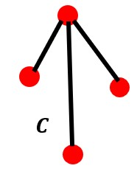 | 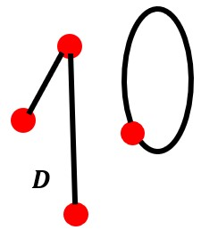 | 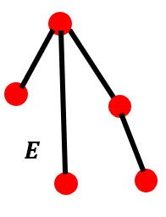

Write your response below:

- Describe each graph below. Explain how many vertices and how many edges it has, and if it is a tree or not a tree.
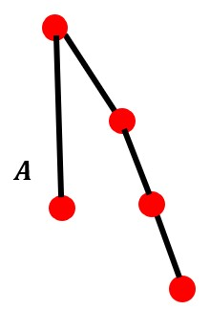 | 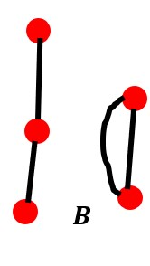 | 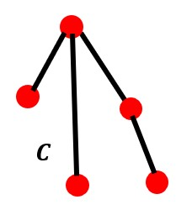

Write your response below:

