Name:

Date:

School:

Facilitator:

6.01 Vertex and Edge Graphs (48 Points)

# ****Incident, Endpoint, Parallel Edges, Loops, and Adjacent Vertices (18 points)****

1. Use the image below to answer the following questions.

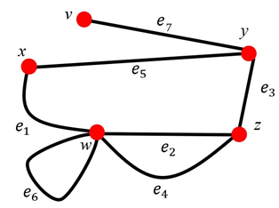

* 1. Name the vertices that are the endpoints of

* 1. Name an edge that is both incident with vertex *w* and *z*.

* 1. Are vertices *y* and *z* adjacent? Why?

* 1. Are vertices *x* and *z* adjacent? Why?

* 1. The edge $e_{6}$ is also called      .
  2. What type of edges are $e_{2} and e_{4}?$ Why?

# ****Paths and Lengths of Paths (30 points)****

1. Identify 3 different paths in the graph below.

Path 1:

Path 2:

Path 3:

1. Answer following questions based on the graph below.

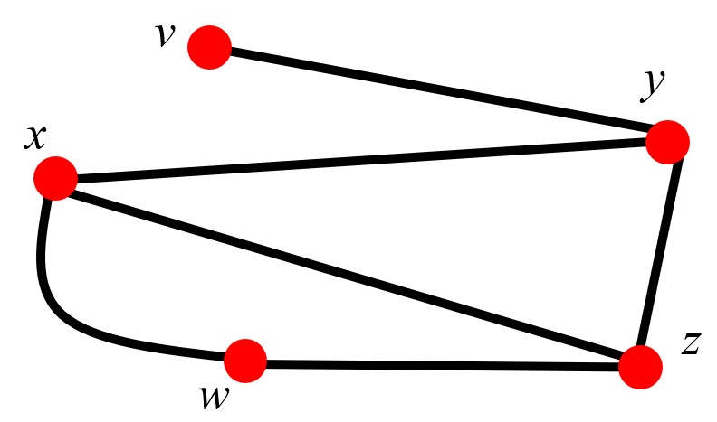

* 1. Find a path of length 3 from vertex *v* to vertex *z*.

* 1. Find a path of length 4 from vertex *v* to vertex *z*.

* 1. Find a path of length 5 from vertex *v* to vertex *x*.

1. Answer following questions based on the graph below.

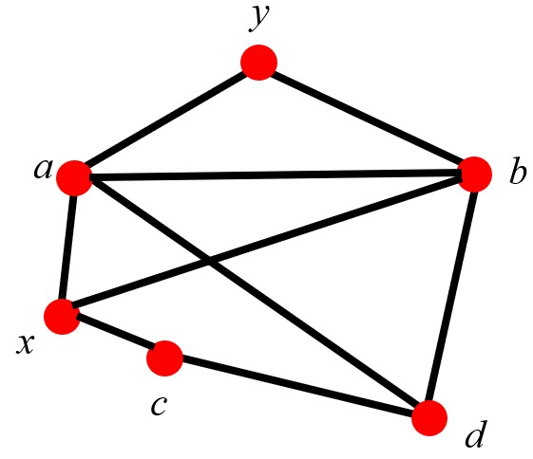

* 1. Find a path of length 3 from vertex *a* to vertex *c* without using the same edge twice.

* 1. Find a path of length 4 from vertex *a* to vertex *d* without using the same edge twice.

* 1. Find all of the shortest paths from vertex *a* to vertex *c*.

* 1. Find the longest path from vertex *b* to vertex *d* without using the same edge twice.