Name:
Date:
School:
Facilitator:

5.04 Lung Capacity Lab

Part A: Tidal Volume and Vital Capacity (4 points)
Read the following information about respiratory capacities and complete the questions that follow.
Your lung capacity allows you to provide your body with the oxygen it needs. In this lab, we will look at 2 different types of lung volumes: Tidal volume and Vital capacity.
1) Tidal volume is the amount of air you breathe in and out during normal at rest breathing. This volume supplies enough oxygen for your cells.
- The average volume is about 500 ml for adult men and women.
2) Vital capacity is the amount of air that can be forced out of your lungs when you take a very deep breath.
- The average adult volume is between 3 and 5 Liters (or 3,000ml-5,000ml).
Questions: (1 point each)
a. The volume of air you breathe in and out during quiet, normal breathing is the .
b. The is the measurement of air from a forced exhalation after a forced inhalation.
c. 500 ml is an average volume of air for tidal volume or vital capacity?
d. 4,000 ml is an average volume of air for tidal volume or vital capacity?

Part B: Spirometer (19 points)
Go to Get Body Smart (https://www.getbodysmart.com/ap/respiratorysystem/physiology/spirometry/menu/menu.html) and choose “Introduction to Spirometers” from the menu. Complete this section by referring to the information on that website.
a. Spirometry is one of the Pulmonary (relating to the lungs) Function Tests (PFT) used to check the health of lungs and respiratory passages. By using the information on the website above, describe what a person does during a spirometry test. (1 point)

b. Choose the “pulmonary diseases” link and describe the difference between an obstructive disease and a restrictive disease. (1 point)

c. Give 2 examples of an obstructive disease and a description.
Obstructive Examples  (2 points total) | Description  (4 points total)

d. Give 2 examples of a restrictive disease and a description.
Restrictive Examples  (2 points) | Description  (4 points total)

e. A recording of a subject's airflow is referred to as a . (1point)
f. The vertical axis of a spirogram indicates airflow (in liters) and the horizontal axis indicates (in seconds). (1 point)
g. The normal ranges for vital capacity are seen in the chart. Height, age, and gender are factors. Look at the appropriate data below and find your predicted vital capacity and record here:
(1 point)
Female Vital Capacity Data
(Height in cm is calculated by converting your height to inches and multiplying by 2.54.)
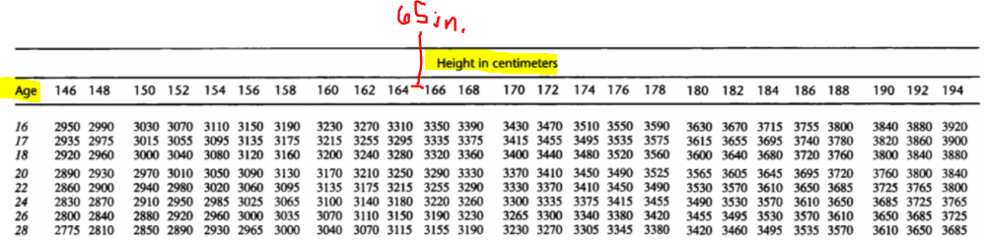
Male Vital Capacity Data
(Height in cm is calculated by converting your height to inches and multiplying by 2.54.)
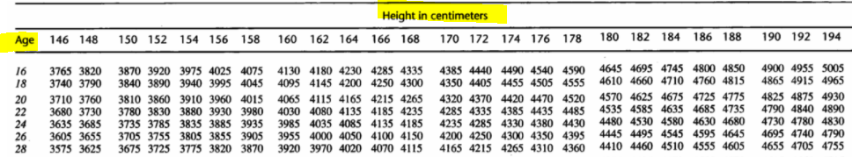
h. What does a reduced rate of airflow on a spirogram indicate? (1 point)
i. What does a reduced volume on a spirogram indicate? (1 point)

Part C: Measuring Your Own Lung Volumes (48 points)
In this activity, you’ll get an approximate measurement of your personal lung volumes at rest, and after you have exercised. Follow the lab procedure instructions carefully. You will need a minimum of an 11 inch balloon (or larger) and a metric ruler. Notice Image 1 illustrating how to obtain an approximate measurement of the air in the balloon by holding it next to the ruler. Put pressure on the balloon to make it as circular as possible.
Image 1: Measuring the Diameter of the Balloon
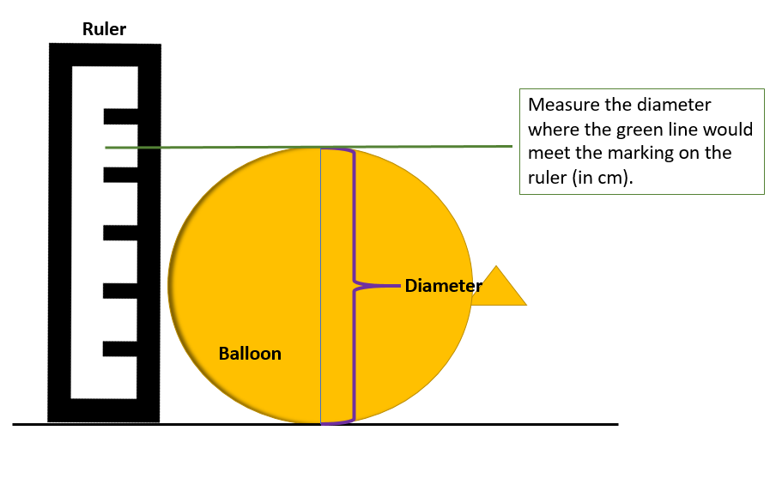
PROCEDURE and RESULTS

a. Obtaining Resting Measurements…
To measure tidal volume:
- take a normal-size breath and exhale it into the balloon. Do not force extra air into the balloon. Twist the balloon to keep the air in. Do not tie the balloon.
- Take the string and use it to measure the diameter of the largest part of the balloon in centimeters. (Refer to Image 1)
- Convert diameter (cm) into volume (cubic centimeters or same as ml) using Image 2 chart below.
- Record the number in the “resting” data table.
- Repeat two more times, and average the tidal volume.
To measure vital capacity:
- inhale deeply taking in as much air as your lungs can hold and exhale forcibly into the balloon. Twist the balloon to keep the air in. Do not tie the balloon.
- Take the string and use it to measure the diameter of the largest part of the balloon in centimeters. (Refer to Image 1)
- Convert diameter (cm) into volume (cubic centimeters or same as ml) using Image 2 chart.
- Record the number in the “resting” data table.
- Repeat two more times, and average the vital capacity.
b. Obtaining Post Exercise Measurements…
Measure tidal volume:
- Jog in place for place for two minutes.
- take a normal-size breath and exhale it into the balloon. Do not force extra air into the balloon. Twist the balloon to keep the air in. Do not tie the balloon.
- Take the string and use it to measure the diameter of the largest part of the balloon in centimeters. (Refer to Image 1)
- Convert diameter (cm) into volume (cubic centimeters or same as ml) using Image 2 chart.
- Record the number in the “jogging” data table.
- Repeat two more times, and average the tidal volume.
Measure vital capacity:
- Jog in place for place for two minutes.
- inhale deeply taking in as much air as your lungs can hold and exhale it into the balloon. Twist the balloon to keep the air in. Do not tie the balloon.
- Take the string and use it to measure the diameter of the largest part of the balloon in centimeters. (Refer to Image 1)
- Convert diameter (cm) into volume (cubic centimeters or same as ml) using Image 2 chart.
- Record the number in the “jogging” data table.
- Repeat two more times, and average the vital capacity.

IMAGE 2: Conversion Chart
Use this graph to convert the diameter (cm) measurement of your balloon into a volume (ml) measurement.
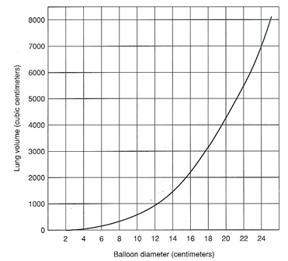

c. Recording the Data
Resting Data Table: Lung Capacity Lab (24 points)
 | Tidal Volume |  | Vital Capacity |  | Your Estimated Vital Capacity
 | Balloon Diameter (cm) | Volume (ml)  *from graph | Balloon Diameter (cm) | Volume (ml)  *from graph
  Height (cm)
  (2.54 cm = 1 inch and 12 inches = 1 ft)
  Weight/Mass (kg)
  (1kg = 2.2 lbs)
  Body Surface Area (m²)
  (see letter “d.”)
  Estimated Vital Capacity (ml)
  (see letter “e”)
Trial
1
2
3
Average

Jogging Data Table: Lung Capacity Lab (24 points)
 | Tidal Volume |  | Vital Capacity |  | Your Estimated Vital Capacity
 | Balloon Diameter (cm) | Volume (ml)  *from graph | Balloon Diameter (cm) | Volume (ml)  *from graph
  Height (cm)
  (2.54 cm = 1 inch and 12 inches = 1 ft)
  Weight/Mass (kg)
  (1kg = 2.2 lbs)
  Body Surface Area (m²)
  (see letter “d.” )
  Estimated Vital Capacity (ml)
  (see letter “e.”)
Trial
1
2
3
Average
d. Calculating BSA

Research has shown that the capacity of a person's lungs is proportional to the surface area of the body. To find your body surface area (BSA), you will need to know your height and weight.
- Calculate your BSA by using the equation below or go to a Body Surface Calculator Online (http://www.calculator.net/body-surface-area-calculator.html?csex=m&bodyweight=140&bodyweightunit=pound&bodyheightfeet=5&bodyheightinch=5&bodyheight=&bodyheightunit=meter&x=70&y=17) and record in the data table.
BSA (m²) = SQRT( [Height(cm) x Weight(kg) ]/ 3600 )
or
BSA = SQRT( (cm*kg)/3600 )
e. Calculating Estimated Vital Capacity form BSA
Once you have calculated your BSA, use this second equation to calculate your estimated vital capacity and record in the data table.
1. Males: BSA x 2500 = estimated vital capacity

2. Females BSA x 2000 = estimated vital capacity

Be sure to calculate for “Resting” and “Jogging” Data Tables.

Part D: Analyze and Conclude on Data (29 points)
ANALYSIS
1. Why is it important to measure tidal volume and vital capacity three times and then get an average? (3 points)
2. How did your estimated vital capacity at rest compare to your estimated vital capacity jogging? Include number values in your response. (3 points)
a. Give an explanation for these result differences. (4 points)
3. How did your measured vital capacity using a balloon compare to the vital capacity you estimated using the formula? Include number values in response. (3 points)
a. Which do you think is more accurate and why? (4 points)
4. How might an athlete's vital capacity compare to a non-athlete? Explain your reasoning.
(5 points)
APPLICATION
Examine this data table of a person who entered into a training program. This person's vital capacity was measured over a 60-day period.
DATA
Day of Training | Vital Capacity
0 | 4800
10 | 4840
20 | 4890
30 | 4930
40 | 4980
50 | 5180
60 | 5260

1. What happened to the person's vital capacity over the course of the training period? (2 points)

2. What probably caused the change? (2 points)
3. How might vital capacity be affected by smoking? (3 points)

