Name:
Date:
School:
Facilitator:

5.03 Respiratory Cycle Activity

Part 1: Breathing and Pressure Changes
Complete the following questions using your lesson notes.
1. Explain the changes in the pressures during inhalation and exhalation as it compares to outside of the body, and why this drives ventilation. (5 points)
2. What happens to the oxygen at the alveoli level? (2 points)
3. What position is the diaphragm in during exhalation? (2 points)
4. Define the following terms: (1 point each)
a. Breathing -
b. Respiration -
c. Inhalation -
d. Exhalation –
e. Ventilation -

Part 2: Chemoreceptors and Breathing
1. A chemoreceptor functions to detect changes in set points of chemicals in our body like carbon dioxide, pH, and levels. (2 points)
2. The normal blood oxygen level range is 95-100%. You become sick with pneumonia and your oxygen level is found to be 90%. What chemoreceptors would detect this and what would they signal to happen? (6 points)
Chemoreceptor | Signals to happen…
a. | b.

3. Would a resting adult respiratory rate of 30 breaths per minute be within the normal range?
(1 point)
4. What part of the brain is where the respiratory center is located? (2 points)
5. If the chemoreceptor in your brain sensed a decreased pH level and an increased CO2 level, what would be the biological response and why? (4 points)
Response | Explanation
a. | b.

6. If your body begins increasing the rate and depth of respirations, what might be the problem? (3 points)

Part 3: Oxygen Loading and Unloading Factors
1. What do the blue circles represent in the image below? (2 points)
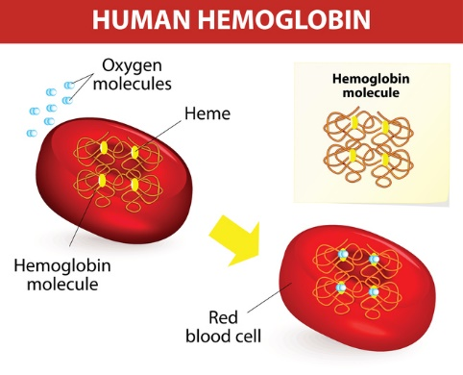
2. Hemoglobin can carry a maximum number of oxygen molecules. (2 points)
3. Describe what the Bohr Effect states: (4 points)

4. Would this be a statement that supports the Bohr Effect? “The normal pH in the blood is between 7.45-7.35. If it drops to 7.34, oxygen will have a higher affinity for Hgb and will not dissociate from it into the tissues. (2 points)
5. If your carbon dioxide levels are low, how will it affect oxygen binding capacity to hemoglobin? (3 points)
6. Describe a scenario that would result in a lower oxygen affinity when carbon dioxide levels are normal and temperature is normal. (3 points)
7. If oxygen is loading onto Hgb, it could be said that it has a low affinity for Hgb. True or False? (2 points)

