Name:
Date:
School:
Facilitator:

5.01 Function of Respiratory System
Answer the following questions correctly.
1) List and describe five functions of the respiratory system?
a.
b.
c.
d.
e.

2. What are the three major parts of the respiratory system?
a.
b.
c.

3. Identify the parts of the diagram function in breathing.
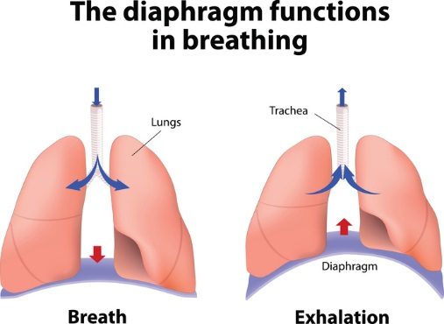
e.
d.
c.
b.
a.

a.
b.
c.
d.
e.

