Name:
Date:
School:
Facilitator:

4.03 ECG Interpretation

ECG Waveforms
Use the ECG image to answer the following questions.
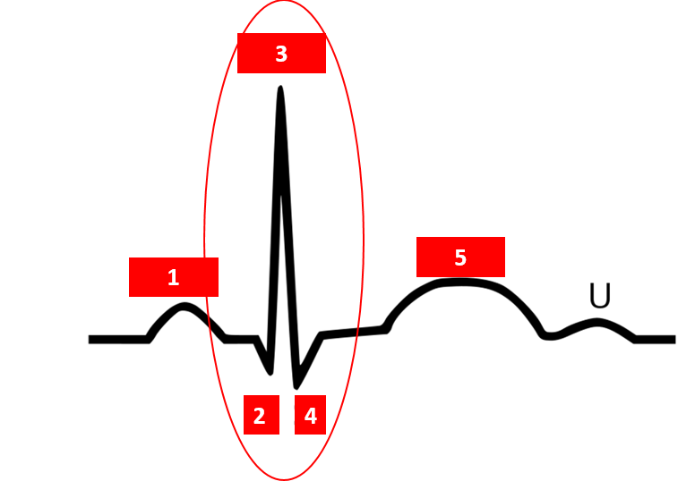
1. Number in the image represents the P wave.
2. Number in the image represents the T wave.
3. The circled numbers 2, 3, and 4 represent the complex.
4. What numbers correspond with atrial depolarization?
5. What number corresponds with ventricular depolarization?
6. An ECG is a recording of the activity of the heart.
7. What number corresponds with the beginning of ventricular relaxation?

ECG Waveforms
8. What abnormality is happening in the beginning of the ECG recording below?
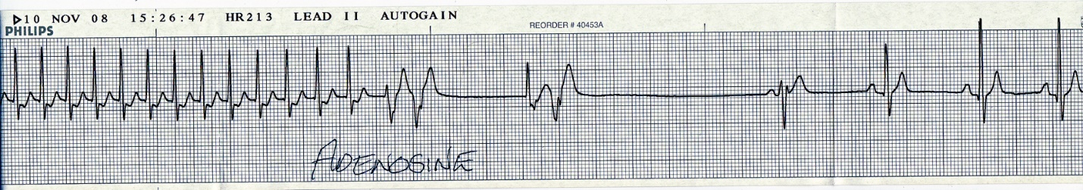

9. What abnormality is happening in the ECG recording below?
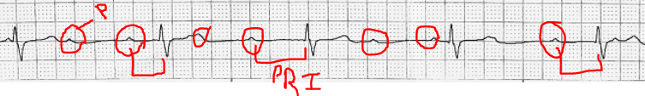

10. In the image below, the ST segment (highlighted areas) of the 12-Lead ECG shows elevation above the baseline. What does that mean?
