Name:
Date:
School:
Facilitator:

3.07 Lines of Defense Concept Map

Concept Map
View the concept map and the information from the lesson to answer the questions on this activity sheet. (Value = 36 points)

Immune System Lines of Defense
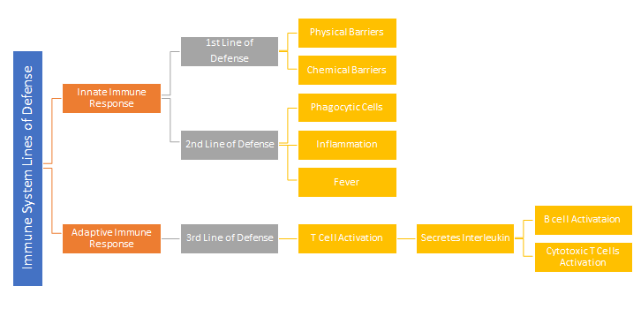

Questions
1. Explain why the 1st line and 2nd lines of defense are considered innate immune responses.
2. List 3 physical barriers of the 1st line of defense and explain how they defend.
Barrier | Explanation
3. List 3 chemical barriers of the 1st line of defense and explain how they defend.
Barrier | Explanation
4. What is the function of the phagocytic cells of the 2nd line of defense?
5. Describe the purpose of the inflammatory response.
6. Describe the complete process of the inflammatory response.

7. List 3 positive benefits of a fever?
Benefit
a.
b.
c.

8. Why is the 3rd line of defense considered an adaptive immune response?
9. What chemical does the T cells secrete resulting in B cell activation?
10. Using the concept map above, what is the result of interleukin secretion?

