Name:
Date:
School:
Facilitator:

3.07 Interactive “Cells of the Immune Systems”

Answer the following questions as you proceed through the activity slides of HHMI “Cells of the Immune System” at this link http://www.hhmi.org/biointeractive/cells-immune-system.

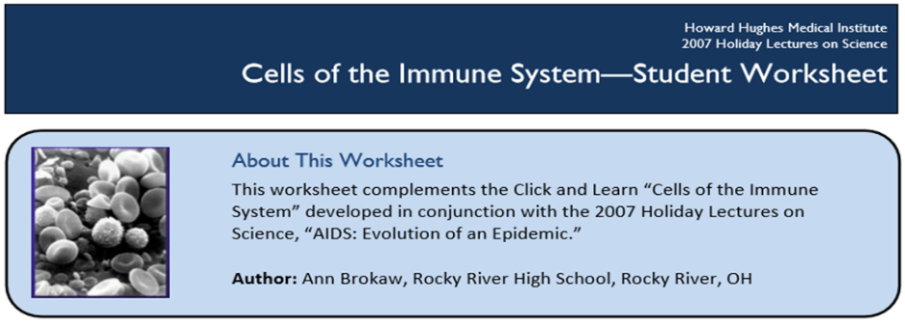

Slides 1-3 Questions
1. Name one type of cell involved in each of the following processes:
a. Innate immunity:
b. Adaptive immunity:
c. Both adaptive and innate immunity:
2. Define innate immune system. (3 points)

3. Where are the cells of the adaptive immune system found in humans?

4. Watch the video on slide 3 and answer the following:
a. How do B cells react to antigens?
b. Which cells conduct the immune system?
c. Which immune cells kill infected cells?

Slides 4-7 Questions
5. What is the purpose of humoral immunity? (3 points)

6. How does antibody specificity arise?
7. Outline the specific steps involved in antibody production in response to infection with human immunodeficiency virus (HIV). (3 points)

8. Define antigen.
9. A macrophage is also referred to as an antigen-presenting cell. Explain why that is an appropriate term. (3 points)

10. Why is antigen-presentation important in fighting infection?
11. T cells are types of white blood cells that have surface receptors that recognize antigens. Does an individual T cell have the ability to recognize more than one type of antigen?
Explain your answer. (3 points)

Slides 8-11 Questions
12. Explain the relationship between the antigen-presenting cells and helper T cells. (3 points)

13. Watch the video on slide 8 and answer the questions below.
a. What specifically results from the release of cytokines by helper T cells?
b. What is the problem with helper T cells carrying out this function in HIV infection?
14. What role do cytotoxic T cells play in fighting infection?
15. What two molecules on the surface of a cytotoxic T cell help the cell recognize infected cells?
16. What is the role of ubiquitin in host cells? Be specific.
17. What is the role of an MHC class 1 protein? Be specific.
18. What is the relationship between an MHC class 1 protein and a cytotoxic T cell? (3 points)

19. What is a potential problem with respect to the timing for when a cytotoxic T cell recognizes a virally infected cell?
20. Summarize the main difference between the action of MHC class 1 and MHC class 2.
(3 points)

