Name:

Date:

School:

Facilitator:

3.02 Lymphatic Structure

**Complete the blanks with the correct information that can be found in the lesson 3.02 material.**

1. The structures located throughout the lymphatic system that filters lymph as it travels through the lymph vessels are the .

2. The structure behind the sternum that matures T cell lymphocytes after they travel from the bone marrow is the .

3. Small masses of lymphoid tissue found at the back of the pharynx are the .

4. Identify the structures in this image labeled “H.”

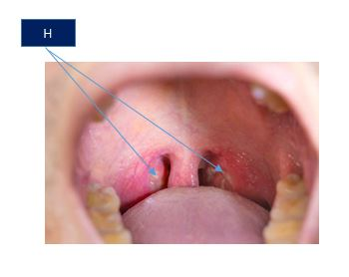

5. Lymph travels through vessels until it reaches the site where it empties into the blood at the .

6. Distinguish between lymph, lymph vessels, and lymph nodes.

|  |
| --- |
|  |

7. Lori has a sore throat and fever. She is going to the doctor to be treated for the illness. What should the doctor be able to palpate in Lori’s neck to determine if she has a strep throat infection (a bacterial infection of the throat)?

## Lymphatic System and Fluid Homeostasis

8. Explain how the lymphatic system maintains fluid homeostasis.

|  |
| --- |
|  |

9. People who have had a bilateral mastectomy (surgical removal of both breasts) have problems with edema (swelling) of the extremities. Predict why this happens, and be specific. (Helpful Resource Link: <http://www.breastcancer.org/treatment/side_effects/lymphedema>)

|  |
| --- |
|  |

## Lymphatic Circulation

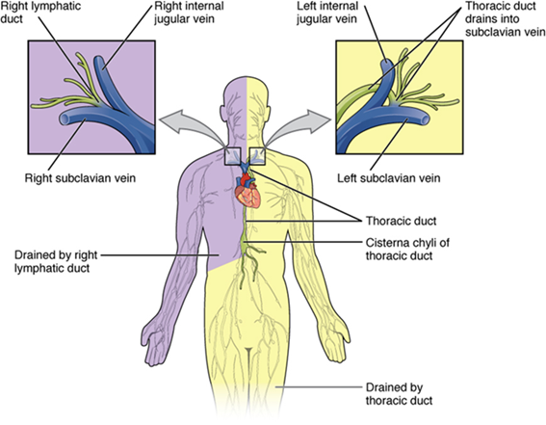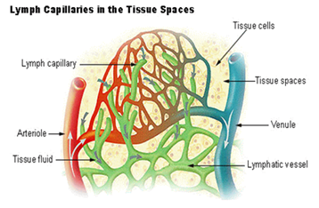**10. Describe the circulation of lymph from the moment it enters the lymphatic system until it is emptied into the bloodstream. You can refer to the diagrams below, and be sure to use the names of structures in your description.**

**Description:**

|  |
| --- |
|  |