Name:

Date:

School:

Facilitator:

3.01 Immune Lymphatic Structures and Function Dropbox

**Refer to the image, and correctly identify the structures. Type your answer into the corresponding number.**

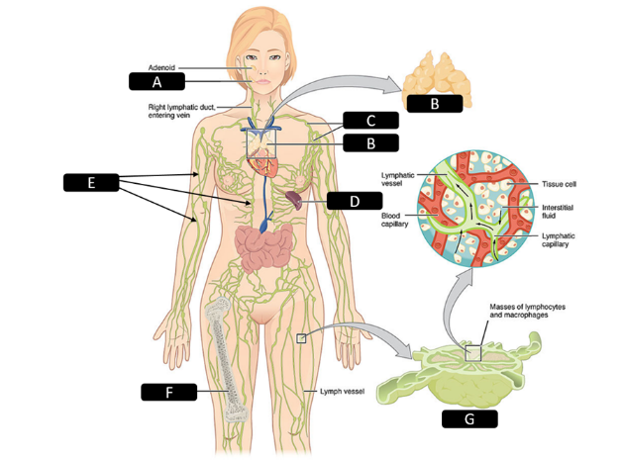

1. **A-**
2. **B-**
3. **C-**
4. **D**-
5. **E-**
6. **F-**
7. **G-**

**Refer to the image and answer the following questions.**

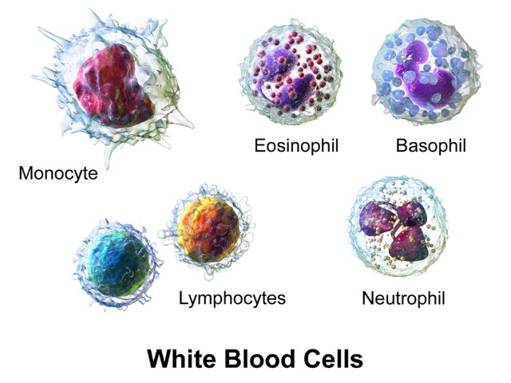

8. Another term for the cells shown in this image is .

9. A general term for a disease-causing organism such as certain types of bacteria is .

10. are foreign substances that trigger a reaction from the immune system.

11. Interstitial fluid flowing through lymph vessels is called .

# Overall Function

**Complete the blanks with the correct information that can be found in the lesson 3.01 material.**

12. The immune system is a collection of cells and organs that function to protect us from disease-causing organisms called .

13. What are the three functions of the immune/lymphatic system?

a.

b.

c.

14. What role does a dendritic cell play in the immune system?

15. A(n)  is a foreign substance that triggers a reaction from the immune system, and it is often found on the surfaces of bacteria and viruses.

16. White blood cells are involved with the immune response, and they are also called .

**17. Tissue fluid is a solution that bathes and surrounds the cells. It is also called interstitial fluid. Where does this fluid originate, and how does this fluid end up in the location surrounding cells?**

**a. Originates from:**

**b. Explanation of how it ends up in this location:**

**18. How many types of white blood cells are part of the immune system?**