Name:
Date:
School:
Facilitator:

2.07 Burns

Diagnose the Burn
Identify each scenario as a 1st, 2nd, or 3rd degree burn by reading the description and viewing the images. Then, complete any additional questions. Use your lesson information on burns as a resource to complete the questions. (Each blank is 1 point)
1) A patient arrives in the emergency room for treatment after spilling hot grease on his hand. You are the nurse in charge of treating this patient. During your assessment, you note his hand is red with blisters. The affected skin does blanche and is moist. What is your diagnosis?
a. Diagnosis of burn degree:
2) A patient arrives in the emergency room for treatment after spending all day outside working in her yard. She has sunburned shoulders and arms that are very painful. You are the nurse in charge of this patient. During your assessment, you note the skin to be red, dry, and without blisters. What is your diagnosis?
a. Diagnosis of burn degree:
b. How long will it take for the burn to heal?

3) Identify this image as a 1st, 2nd, or 3rd degree burn:
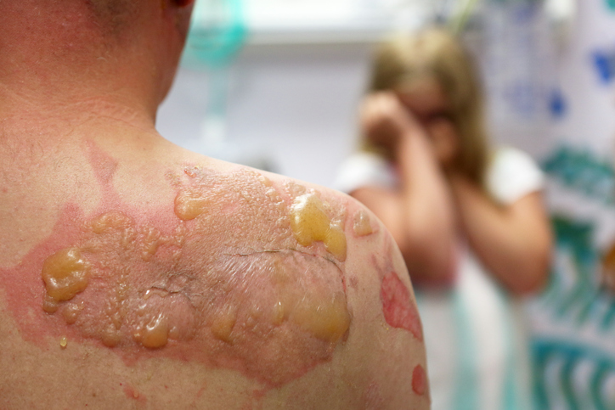
a. Degree of burn:
b. What layers of the skin are affected in this type of burn?

4) Which of the following images (Image 1, 2, or 3) is a 3rd degree burn?
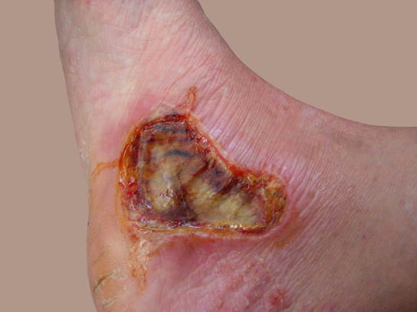
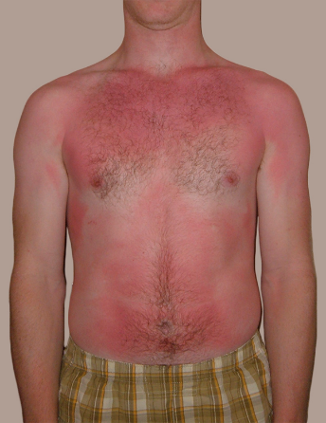
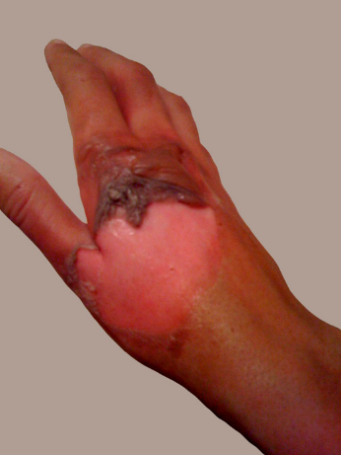
Image 1 Image 2 Image 3

b. Would a 3rd degree burn be considered a “partial thickness” or a “full thickness” burn?
5) You are a physician treating a patient with a burn that looks like this image:
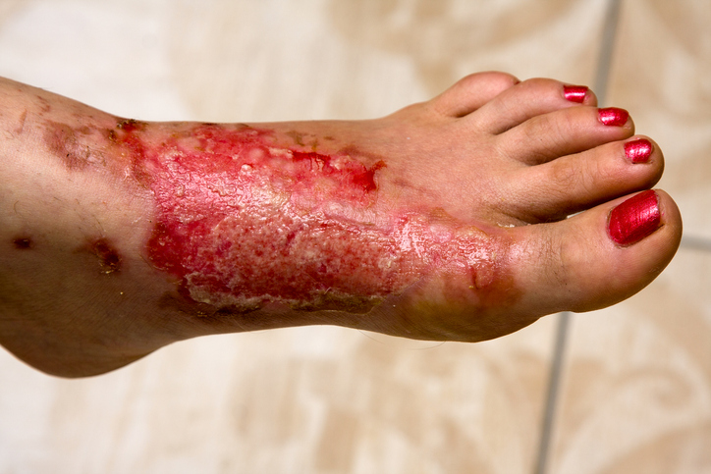

a. What is your diagnosis for the degree of burn?
b. Would this type of burn lead to contractures?
c. You observe this burn to cover the entire anterior and posterior surface of the same leg. What percent of body surface area (BSA) is affected?

