Name:

Date:

School:

Facilitator:

2.04 Accessory Structure Identification

# Accessory Structures – Image 1

**Refer to the image, and correctly identify the structures. Type your answer into the corresponding number. Make sure your answers relate to the anatomy of the hair and sweat glands!**

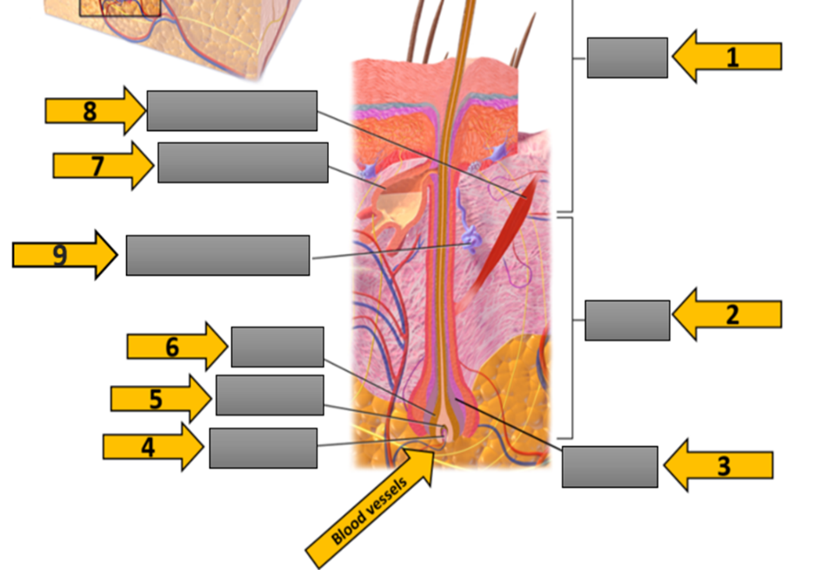

**1.**

**2.**

**3.**

**4.**

**5.**

**6.**

**7.**

**8.**

**9.**

# Accessory Structures – Image 2

**Refer to the image, and correctly identify the structures. Type your answer into the corresponding number.**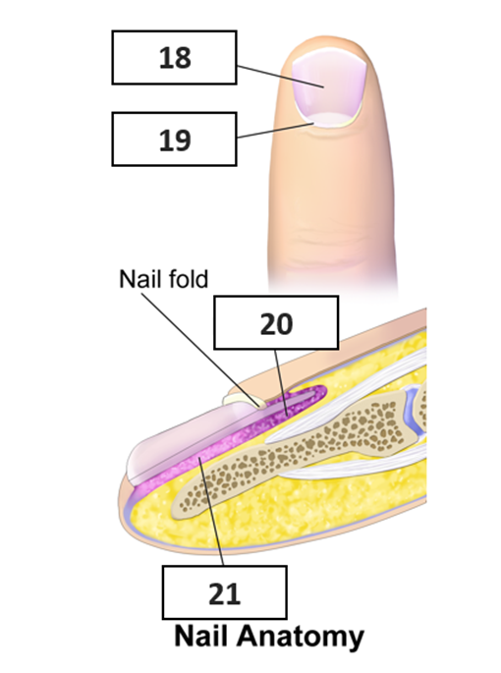

1. #18
2. #19
3. #20
4. #21       (Bonus)

**Fill in the blank.**

1. The accessory structure of the integumentary system that functions to protect fingers and toes from mechanical stress are the      .
2. secrete a lipid mixture that lubricates and waterproofs the skin.
3. The accessory structure of the integumentary system that plays a role in thermoregulation through the secretion of sweat is the      .
4. sweat glands are associated with hair follicles in the armpits and genital regions, and secrete a water, salts, and organic compound.
5. The       is the region of the nails where there are dividing cells and nail growth occurs.
6. The       helps anchor the nail body.