Name:

Date:

School:

Facilitator:

2.03 Hair Identification

# Accessory Structures – Image 1

**Refer to the image, and correctly identify the structures. Type your answer into the corresponding number.**

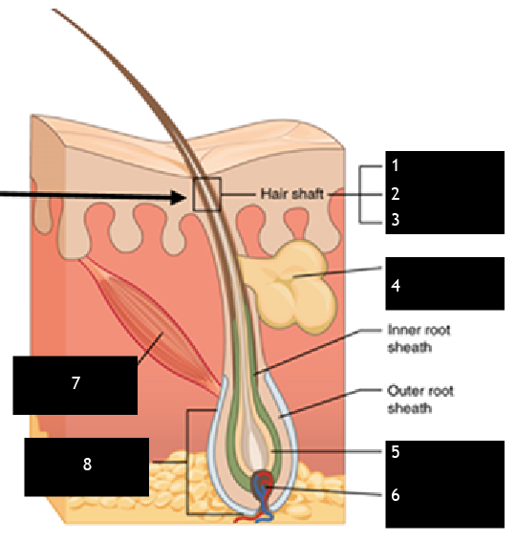



**Fill in the blank.**

1. The       phase of hair growth lasts about 2 to 4 months and involves a resting phase of the follicle with no growth.
2. The       phase of hair growth lasts 2-7 years, and consists of rapidly dividing cells at the root of the hair pushing the hair shaft up and out.
3. The       is the structure of the hair containing blood vessels to nourish the cells.
4. The       is the tunnel-like segment where the hair grows.