Name:

Date:

School:

Facilitator:

1.08 Virtual Histology Lab

**Complete Parts A – E of this lab.**

**Part A: Histology Overview**

**Using your lesson notes, complete the following.**

1. is the study of tissues.
2. List the 4 major types of tissues found in the body:

a.

b.

c.

d.

1. Two or more cells working together to perform a specific function are a      .

**Identify each microscopic image by its tissue type:**

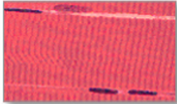



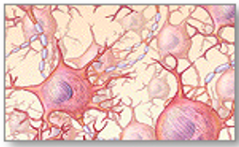



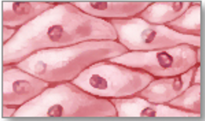



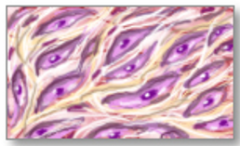



**Part B: Epithelium**

1. **Location:** Epithelial tissue is located       in the body.
2. **Function:** Epithelial tissue functions to      .

## Classification

Epithelial tissue is classified by its **SHAPE** and number of **LAYERS**. (See the table below showing these classifications.)

* **SHAPES**: are named squamous, cuboidal, or columnar
* **LAYERS**: are named simple (one layer of cells), stratified (more than 1 layer of cells), or pseudostratified (1 layer of cells that appears to be multiple layers)

## Table of Epithelial Tissue Classifications

|  |  |
| --- | --- |
| **Epithelial Tissue Classifications** | **Explained** |
| Epithelium royalty-free stock vector art | This image illustrates a **flat**, **scale-like** cells: **squamous**     * It shows **1 layer**: **simple**. * The lower portion of the image shows **more than 1 layer**: **stratified**. |
| Epithelium royalty-free stock vector art | This image illustrates **cube-shaped** cells: **cuboidal.**   * It shows **1 layer**: **simple**. * The lower portion of the image shows **more than 1 layer**: **stratified**. |
| Epithelium royalty-free stock vector art | This image illustrates **rectangular-shaped** cells: **columnar**.   * It shows **1 layer**: **simple**. * The middle portion of the image shows **more than 1 layer**: **stratified**. * The lower portion of the image shows 1 layer that appears to be **multi-layered**: **pseudostratified**. |

1. Describe the appearance of squamous cell epithelium.
2. Describe the difference between simple and stratified.
3. Summarize the difference between stratified columnar and simple cuboidal epithelium.

**Part C: Connective Tissue**

1. List 3 functions of connective tissue:
2. What is the noncellular component of connective tissue where ground substance is found?
3. The nonliving, highly hydrated material in the ECM is called       that consists of protein and carbohydrate molecules, and acts as a lubricant and barrier.

Adult connective tissue is classified into **3 broad groups** according to the characteristics of their ground substance and the types of fibers found within the ECM: **tissue proper**, **supportive**, and **fluid**. (See the concept map for these categories).

## Concept Map of Connective Tissue Categories

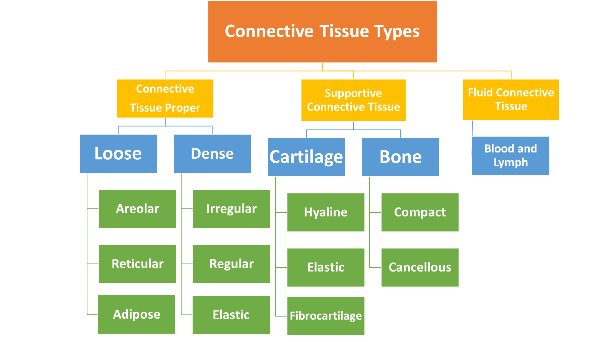

1. How is bone connective tissue different from cartilage connective tissue?

1. This is an image of **compact bone**. What are the concentric circular regions (“A” in the diagram) called?

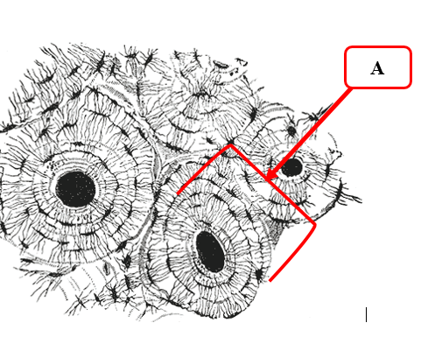

1. This image is of a type of loose connective tissue involved in storing fats. What is its name?        
   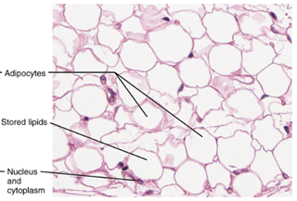

**Part D: Muscular Tissue**

**Read the following section about the 3 types of muscle tissue and then complete the questions in the following sections.**

|  |
| --- |
| Overview of Muscle Tissue Types: Muscular tissue has contractile properties and are classified into 3 categories: skeletal, smooth, and cardiac.  Skeletal Muscle Characteristics and Components   * contains striations (3) – dark stained areas of tissue * many nuclei (4) for each muscle cell * **Location**: Muscles of the bone     Smooth Muscle Characteristics and Components   * spindle-shaped cells (6) * with 1 large nucleus (7) per cell * **Location**: Muscles of organs such as the bladder     Cardiac Muscle Characteristics and Components   * striated * branched fibers (9) (sometimes described as Y-shaped) * single central nucleus (10) * intercalated discs (8) (a thick plasma membrane) * **Location**: Muscle of the heart |

1. Which of the 3 types of muscle tissue does NOT exhibit striations when stained?
2. Which muscle tissue has intercalated discs (thick plasma membranes)?
3. Complete this chart comparing muscle tissue types by marking each cell with “YES” or “NO.”

|  |  |  |  |  |  |  |
| --- | --- | --- | --- | --- | --- | --- |
|  | Striations | Intercalated Discs | Multi-nucleated | Heart | Bladder | Branching |
| **Cardiac** |  |  |  |  |  |  |
| **Skeletal** |  |  |  |  |  |  |
| **Smooth** |  |  |  |  |  |  |

**Part E: Nervous Tissue**

**Read the information below about nervous tissue and the cells that make up this tissue. Then, answer the questions that follow.**

|  |
| --- |
| Overview Nervous tissue functions in sending and receiving messages. A **neuron** is the cell of nervous tissue. This diagram illustrates parts of a nerve cell (neuron).   * **Dendrites** – receive information * **Cell body** – contains the nucleus * **Axon** – part of the neuron where information in the form of electricity travels and is sent to another cell/axon is insulated by the **myelin sheath**   Blausen 0672 NeuralTissue.png  https://upload.wikimedia.org/wikipedia/commons/0/0b/416_Nervous_Tissue-new.jpg |

**Identify the nervous tissue structures in the slide images.**

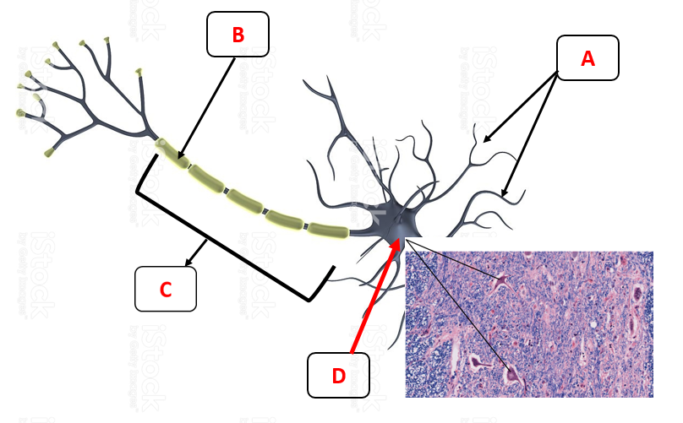



Go to the **Guillain-Barré Fact Sheet** (<https://www.ninds.nih.gov/Disorders/Patient-Caregiver-Education/Fact-Sheets/Guillain-Barr%C3%A9-Syndrome-Fact-Sheet>) to find information about this disease affecting nervous tissue. Complete the following questions.

1. What happens to the myelin sheath in a person who develops Guillain-Barré?
2. What are the symptoms of Guillain-Barré?
3. What causes the disease, and is it contagious?
4. What is the importance of the myelin sheath that covers the axon of a neuron?