Name:
Date:
School:
Facilitator:

1.06 Anatomical Terminology Exercise

Body Planes
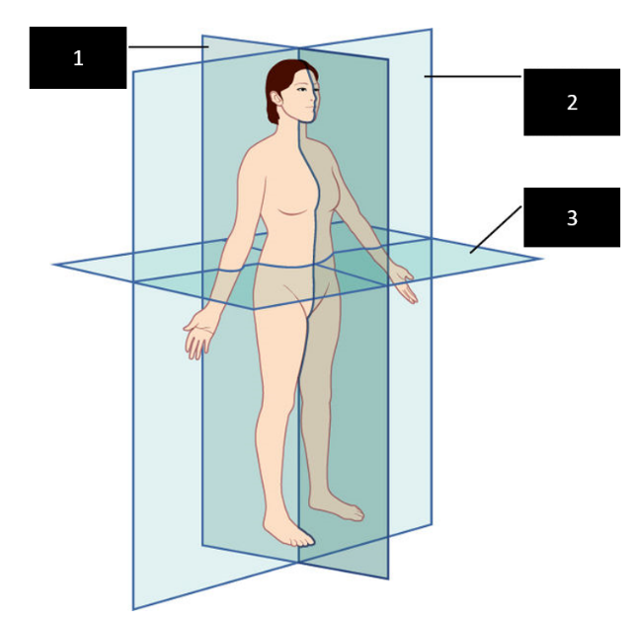
Directions: Write the name of the corresponding body plane from the image.
1.
2.
3.

Directional Terms
Directions: Using the image, complete the blank with the corresponding name of the directional term from the list below.
LIST: Anterior, Posterior, Superior, Inferior, Lateral, Medial, Proximal, Distal, Caudal, Cranial, Left, Right.
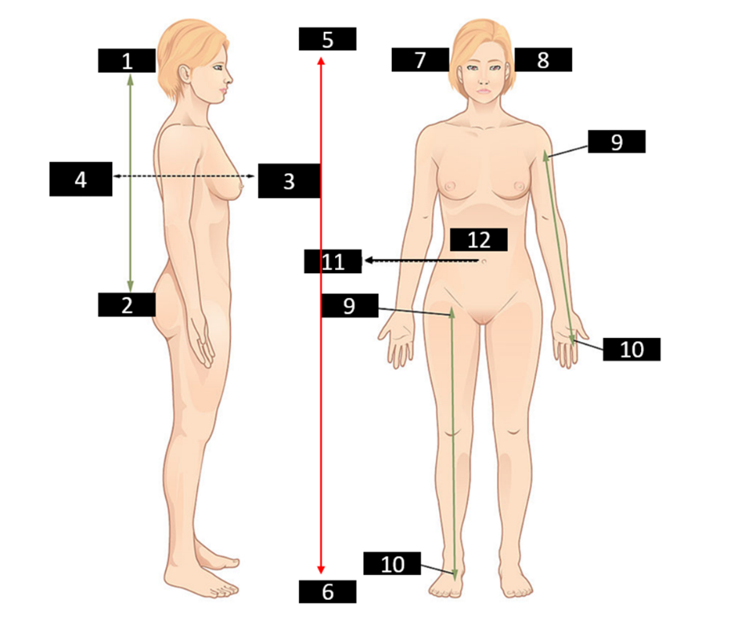
1.
2.
3.
4.
5.
6.
7.
8.
9.
10.
11.
12.

True or False
Directions: Examine each of the following statements as true or false. If the statement is true, type T; if the statement is false, type F and also correct it by replacing the underlined word with the correct one.
1. A midsagittal plane divides the body into equal left and right sides.
2. A horizontal plane divides the body into anterior and posterior parts.
3. The chest is inferior to the belly.
4. The wrist is distal to the elbow.
5. In anatomical position the palm is turned to the back.
6. In the prone position, a person is lying face-up.
7. The skin is deep to the heart.

Eliminate the Odd One
Directions: Type the word that does NOT belong and explain your choice briefly.
1. palmar – ventral – caudal – anterior

2. plantar – sagittal – horizontal – frontal

3. cephalic – superior – distal – cranial

Synonyms
Directions: Type the word that means the same as each of the following.
1. dorsal
2. cranial
3. inferior
4. frontal
5. anterior

Opposites
Directions: Type the word that means the opposite of each of the following.
1. superior
2. lateral
3. ventral
4. proximal

Body Regions
Directions: Type the number from the image that corresponds with body region term.

1. Cervical
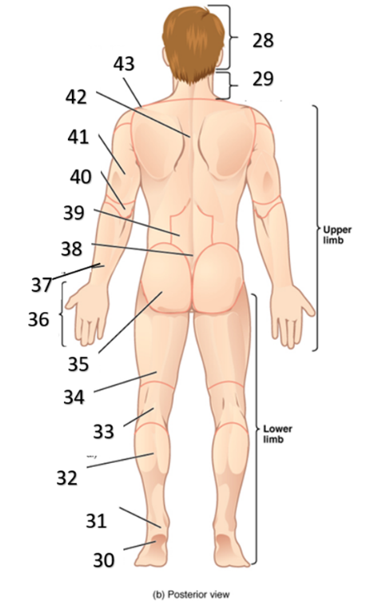
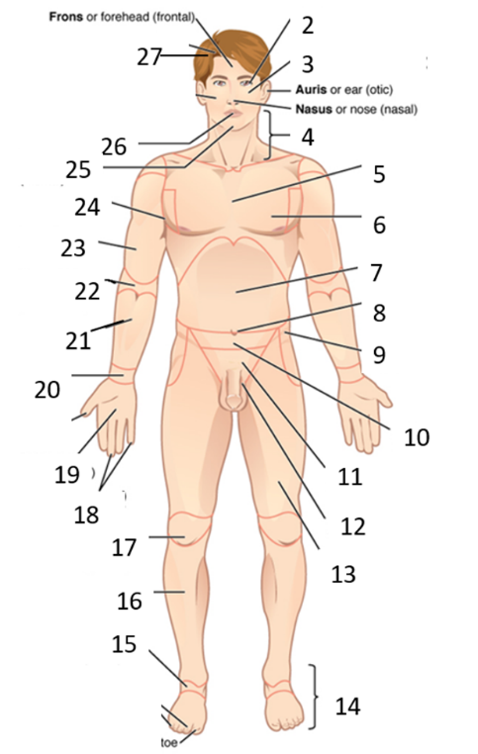
2. Sacral
3. Plantar
4. Gluteal
5. Carpal
6. Lumbar
7. Popliteal
8. Dorsal
9. Antecubital
11. Buccal
13. Pedal
14. Coxal
15. Mammary
16. Palmar

