Name:

Date:

School:

Facilitator:

1.05 Abdominopelvic Regions and Quadrants

Answer the question with the correct response.

1. What abdominopelvic region does “B” represent in the image?

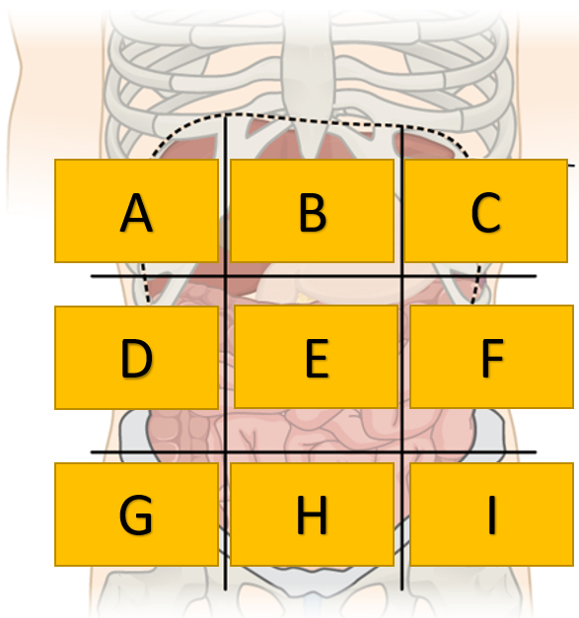

2. What letter represents the left iliac region in the image?



3. What letter represents the LLQ in the image?

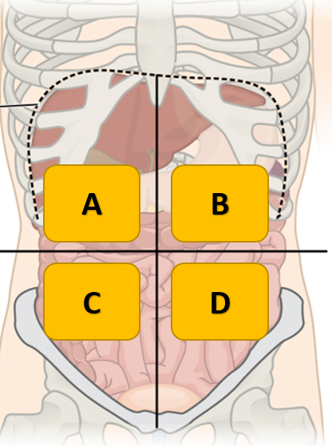

4. Stomach pain would most likely be felt in which quadrant?



5. Name the 9 abdominopelvic regions in this diagram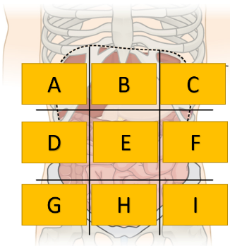.

A.

B.

C.

D.

E.

F.

G.

H.

I.