Name:

Date:

School:

Facilitator:

1.04 Body Cavities

**Match the correct term with the body cavity shown in the image.**

1. Identify the body cavity labeled as #1 on the image:

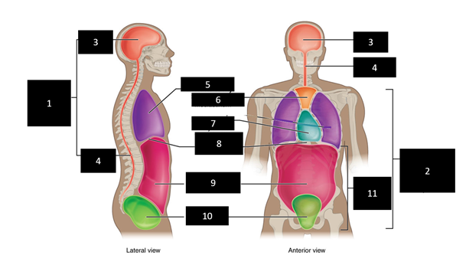

2. Identify the body cavity labeled as #9 on the image:

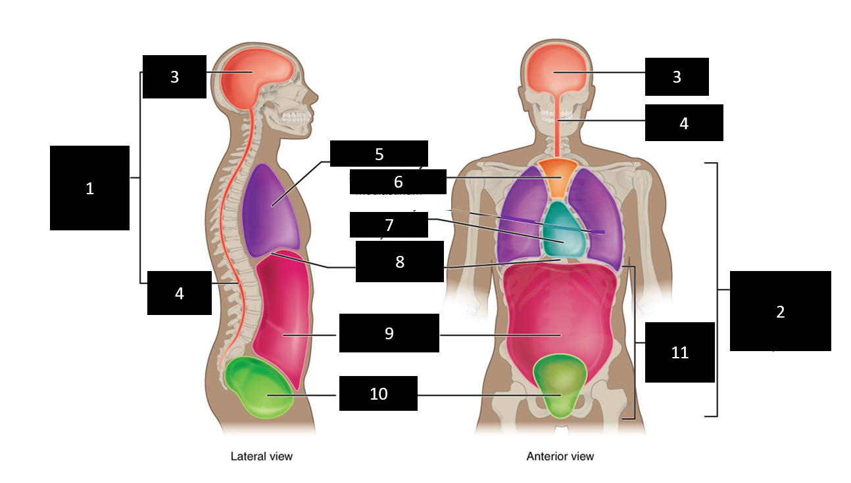

3. Identify the body cavity labeled as #7 on the image:



4. Identify the body cavity labeled as #10 on the image:



5. Identify the body cavity labeled as #3 on the image:

