Name:
Date:
School:
Facilitator:

1.03 Homeostasis Video
Answer the following questions:
1) Define negative feedback.
2) Define homeostasis.
3) What is the optimal blood glucose level in the body (or set point)?
4) What happens if the blood glucose level rises above the set point?
5) What happens when the blood glucose level falls below the set point?

Identify the following three components of blood glucose homeostasis if blood sugar falls below 70 mg/dL:
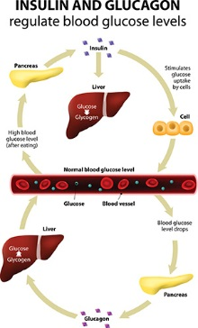
6) Set Point:
7) Receptor:
8) Effector:
9) Using the illustration, summarize the body’s process to maintain homeostasis of blood glucose levels:
10) Describe why this is considered a negative feedback system:

